Syllabus: Anatomy and Physiology I - Lab
Course Number: BIOL 2101
Semester & Year:
Instructor Information
Name: Katie Teer
Office: Biology 31
Telephone: 903-823-3433
E-mail: kathleen.teer@texarkanacollege.edu
Office Hours:
Days | Times
Monday/Wednesday | Varies by Semester
Tuesday/Thursday | Varies by Semester
Friday | By appt. only

Required Materials

Lab Manual – Purchased from the TC Bookstore
There is no textbook for this course

Optional Materials

Pens, binder for handouts, colored pencils, markers, highlighters, index cards

Student Learning Outcomes for the Course
The lab provides a hands-on learning experience for exploration of human system components and basic physiology. Systems to be studied include integumentary, skeletal, muscular, nervous, and special senses. ~ Academic Course Guide Manual (ACGM) - 2021
Learning Outcomes
Upon successful completion of this course, students will:
1. Apply appropriate safety and ethical standards.
2. Locate and identify anatomical structures.
3. Appropriately utilize laboratory equipment, such as microscopes, dissection tools, general lab ware, physiology data acquisition systems, and virtual simulations.
4. Work collaboratively to perform experiments.
5. Demonstrate the steps involved in the scientific method.
6. Communicate results of scientific investigations, analyze data and formulate conclusions.
7. Use critical thinking and scientific problem-solving skills, including, but not limited to,
inferring, integrating, synthesizing, and summarizing, to make decisions, recommendations and predictions. ~ Academic Course Guide Manual (ACGM) – 2021

Grade
A | 90-100
B | 80-89
C | 70-79
D | 60-69
F | 59-below
Grading Scale

Be sure to check the gradebook in Moodle/Jenzabar frequently regarding your grades and attendance.
Once a grade has been entered, you will have 1 week to dispute that grade.
After the time frame has passed for disputes, the grade will be locked in and will no longer be subject to change.

Student Assessment – Grade Calculation
Lab Practical Exams – 70%
- NO MAKE UPS AVAILABLE!!
- No exam grade will be dropped.
- All exams are equally weighted.
- The highest grade that can be made on any test (including any bonus points) is a 100.
- All tests are to be taken during regular class time in the classroom unless otherwise indicated.
  - See the schedule for specific dates!
- All practicals are in-person and open response with NO WORD BANK
  - They will start at the beginning of class and will be timed
  - Spelling counts!!

Quizzes, Dissections, Labs, and other Assignments - 30%
- Will be assigned through the TC Course Page (Moodle), in class or online.
- The lowest grade in this category will be dropped.
- Missed in-class assignments CANNOT be made up!!
- No late work will be accepted. Be sure to complete all assignments by the due date.

Class Schedule (Varies by Semester)
This schedule is tentative and subject to change. Any changes will be announced in class.

Week | Dates | Content
Week 1
M | --- | ---
W |  | Exercise 1 – Anatomical Language  Exercise 2 – Organ Systems & Body Cavities *  Exercise 3 – Compound Light Microscope *  Exercise 4 – Cell Structure & Cell Cycle *
Week 2
M |  | Exercise 2A – Rat Dissection  Test Review for Lab Practical 1
W |  | Lab Practical 1 – Language, Systems, Microscope, Cell – 50Q  Exercise 6C – Tissue Identification – Muscle Tissue  Exercise 6D – Tissue Identification – Nervous Tissue
Week 3
M |  | Exercise 6A – Tissue Identification – Epithelial Tissue  Exercise 6B – Tissue Identification – Connective Tissue  Exercise 7 – Integumentary System*
W |  | Exercise 9 – Part 1: Axial Skeleton – The Skull  Exercise 9 – Part 2: Axial Skeleton – Facial Bones and Sinuses  Exercise 5 – Osmosis Lab*
Week 4
M |  | Labor Day Holiday – No Class
W |  | Lab Practical 2 – Histology & Integumentary System – 50Q (PowerPoint format)  Exercise 9 – Part 3: Axial Skeleton – Thoracic Cage & Vertebrae
Week 5
M |  | Lab Practical 3 – Axial Skeleton – 50Q  Osmosis Lab Report DUE at the beginning of class  Exercise 10A – Appendicular Skeleton: Part1 – Pectoral Girdle  Exercise 10B – Appendicular Skeleton: Part 1 – Upper Limbs
W |  | Exercise 10C – Appendicular Skeleton: Part 2 – Pelvic Girdle  Exercise 10D – Appendicular Skeleton: Part 2 – Lower Limbs
Week 6
M |  | Lab Practical 4 – Appendicular Skeleton – 50Q
W |  | Exercise 14 – Skeletal Muscle – Part 1  Exercise 14 – Skeletal Muscle – Part 2
Week 7
M |  | Lab Practical 5 – Skeletal Muscle – 50Q  Exercise 20 – The Brain & Ventricles & Meninges
W |  | Exercise 17 – The Spinal Cord  Exercise 24 – Part 1 – The Eye  Exercise 24 – Part 2 – The Ear
Week 8
M |  | Sheep Brain Dissection  Cow Eye Dissection  Final Exam Review
W |  | Lab Practical 6 – Nervous System – 50Q
Week 9
M |  | Lab Practical 7 – Comprehensive Final – 50Q
W |  | No Class

Technology Help
School Web Address: www.texarkanacollege.edu
If you cannot access internet from home, work, etc., there are places on campus to access your TC Course page and complete the required assignments. You are welcome to use the computers in the TC Library.
If you are in need of help regarding accessing your email or your TC Course page or logging in please contact the TC Service Portal at 903-823-3030 or you may contact them through a working computer at: https://support.texarkanacollege.edu/?sso_token=474125a9e46eab415a7c46bf1f85af33b300f025

Computer Requirements
All students are required to have a computer with internet access for classes.
- Smart phones, iPads, Androids, Chromebooks, etc., are NOT acceptable substitutes. For more information, please view our Computer Requirement Policy here.
- Need to buy a laptop computer? Check our TC Bookstore. Special student pricing is available and financial aid may be used for the purchase. A list of internet Wi-Fi service providers can be found here.
- Wifi is available on campus for TC students. See our Wifi hotspots on campus here. If you are having trouble accessing TCNet Wifi contact the TC Service Desk:
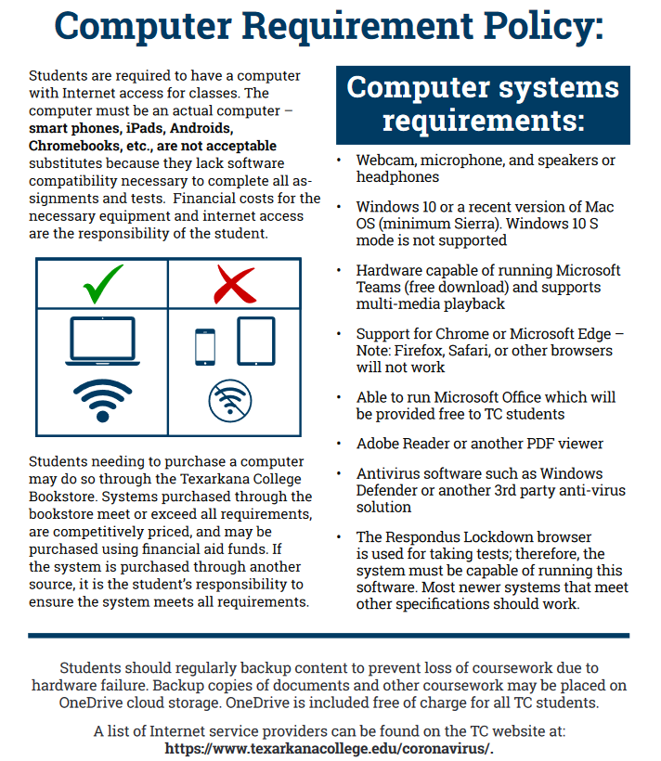
  - Submit a ticket online
  - Email the Service Desk
  - Call (903) 823-3030

Attendance Policy – non-traditional classes (hybrid, web, hy-flex)
Attendance for internet classes is based on accessing course materials and submitting assignments. If a student stops accessing materials and sending assignments, the date of the last report of activity will be submitted to the Registrar, and a grade of “F” will be recorded. As a result, the student may lose scholarships or grants or have to repay funds already rewarded. The TC absentee policy is pasted below:

Absentee Policy
Texarkana College attendance policy allows students to be dropped by instructors for excessive absences. TC considers excessive absences to equate to anything greater than 15% of the class. In an 8-week term, this means that instructors may drop students for attendance if a student’s absences exceed more than one week of class meetings and/or online assignments. In a 16-week term, instructors may drop students for attendance if student absences exceed more than two weeks of class meetings and/or online assignments.
Faculty members are not obligated to provide opportunities for students to make-up missed assignments and tests due to a student’s absence from class.
A student should not stop attending a class without formally withdrawing from the course by the institutions published Last Day for Students to Drop. If a student stops attending class after the published Last Day for Students to Drop, the student may receive a grade of “F” in the class. The instructor will submit the last date of attendance for students receiving a grade of “F” or “W”.
Withdrawal from a course(s) may affect a student’s current or future financial aid eligibility. Students should consult the Financial Aid Office to learn both short and long term consequences of a withdrawal.

Excused Absences
A student’s absence due to school trips and/or school business will not be counted against a student’s allowable number of absences. Military duty and absences for Holy Days (FBD LEGAL) are covered in a separate section of the catalog and the student handbook. These are the only excused absences that are considered by Texarkana College. Responsibility for work missed for any absence is placed on the student. Instructors are required to allow students to make up work missed if the absence is due to military duty* or religious holy days when students follow the correct notification procedures. Instructors are not required to allow students to make up work for absences due to other reasons. Make-up policies are listed in each individual instructor’s syllabus.

Maximum Allowable Absences
After official registration, the following number of unexcused absences will be the maximum allowable before a student may be dropped from the class. Mandated program certification requirements detailed for certain programs regarding the maximum allowable unexcused absences takes precedence over the following information.
Roll will be taken each class. A student with 3 absences may be dropped from the course for lack of attendance per the TC Handbook Attendance Policy. If extenuating circumstances arise, please set up a time to discuss this with your instructor. If an enrolled student stops attending class and chooses to receive an F, the last date they attended will be listed on the final grade sheet and they will most likely have to pay back money received from grants or scholarships. You can check your absences through myTC (Jenzabar)!

Make-up Policy
No make-up lab exams or assignments allowed.

Class Behavior
There will be a ZERO TOLERANCE policy for any behavior that is disruptive and prevents or deters classroom learning. This includes, but is not limited to, ANY use of vulgar language or rude behavior towards the instructor or any other student in the class. Violation could result in being asked to leave the class, withdrawal from the course, &/or investigation by the Dean of Students.
If a student creates a disruption in the Testing Center, the student could face the following consequences: zero on the assignment (even a test), withdrawal from the course (WF on transcript), &/or investigation by the Dean of Students.
Examples of a disruption include but are not limited to: being rude or disrespectful to the staff in the testing center, academic misconduct (cheating), not following testing center rules and regulations

Financial Aid:
Attention! Dropping this class may affect your funding in a negative way! You could owe money to the college and/or federal government. Please check with the Financial Aid office before making a decision.
If you are dropped from the lecture course for any reason, you will be automatically dropped from the lab course.

Cell Phone Policy
During testing, cell phones should NOT be VISIBLE. If a cell phone or any other electronic device is visible, regardless of if it is used, it will result in a zero for the assignment and reported to the Dean of Students as academic dishonesty and could lead to being withdrawn from the course with a grade of “F”. This includes Smart Watches. These should not be on your person while testing!

Academic Integrity Statement
Scholastic dishonesty, involving but not limited to cheating on a test, plagiarism, collusion, or falsification of records will make the student liable for disciplinary action after being investigated by the Dean of Students. Proven violations of this nature will result in the student being dropped from the class with an “F”.
This policy applies campus wide, including TC Testing Center, as well as off-campus classroom or lab sites, including dual credit campuses. This information can be found in the Student Handbook at https://texarkanacollege.edu.
The following are examples of academic dishonesty:
1) copying an answer sheet from another student during an exam
2) providing information to another student about a test
3) cell phone usage during an exam (usage refers to ANYTHING that involves a cell phone, including but not limited to: silencing an alarm, viewing documents, texting (viewing or sending), answering a call, browsing the internet, checking the time, etc.)
a) cell phones MUST be concealed and cannot be retrieved during an exam
b) cell phones cannot be answered during an exam (this includes texting)
4) opening other tabs while taking a computerized version of the test (in the testing center or at home)
During an exam (lecture or lab), a student will not be allowed to wear a hat or sunglasses, nor will students be allowed to leave the room unless they are finished with the exam. Once a student has left the exam room, the exam will be considered complete, and the student may no longer make changes or return and continue the exam.
Chat GPT: The use of Chap GPT may be considered academic dishonesty. Check with your instructor to be sure.
The instructor reserves the right to determine what constitutes an act of cheating, although the above are provided as examples.
Disability Act Statement:
Texarkana College complies with all provisions of the Americans with Disabilities Act and makes reasonable accommodations upon request. Please contact Tonja Blasé at 903-823-3349.
If you have an accommodation letter from their office indicating that you have a disability which requires academic accommodations, please present it to the instructor so we can discuss the accommodations that you might need for this class. It is best to request these changes at the beginning, if not before the start, of class so there is ample time to make the accommodations.
If you are dropped from the lecture course, you will be automatically dropped from the lab course.

Basic Needs Security Statement
Any student who has difficulty affording groceries or accessing enough food to eat every day, or who lacks a safe and stable place to live and believes this may affect their performance in this course or ability to remain in school, is urged to contact Tonja Blasé, Director of Student Retention, at 903-823-3349 for support. Furthermore, please notify the professor if you are comfortable in doing so.

