Syllabus: Design I
Course Number: ARTS 1311
Semester & Year: Fall 2022
Instructor Information
Name: Dr. Angela Melde
Office: 903-823-3277
Telephone: 903-276-7784
E-mail: angela.melde@texarkanacollege.edu
Office Hours:
Mon./Wed. 3:30 - 5:00
Tues./Thurs. 2:00 - 5:00
Fri. 12:00 - 2:00
Course Description
An introduction to the fundamental terminology, concepts, theory, and application of two dimensional design.
Student Learning Outcomes
Upon successful completion of this course, students will:
1. Identify and apply the elements of art and principles of two-dimensional design.
2. Employ discipline specific vocabulary in the evaluation of two-dimensional design problems.
3. Demonstrate creative skill in aesthetic problem solving within assigned parameters.
4. Demonstrate an appropriate level of professional practice, including safety, craft and presentation.

Grading Scale
To determine your grade at any time during the quarter, use the following guide: add up the total number of points earned to date and divide by the total points possible to date. Use the percentage scale above to determine your grade.

Final grades will be assigned a letter grade. Throughout the semester, section
assignment grades will be calculated in a point system. ALL ASSIGNMENTS ARE DUE THE DAY SPECIFIED ON THE SYLLABUS CALENDAR, AT THE BEGINNING OF CLASS ON THAT ASSIGNED DAY. Students must consult with the instructor to see if work will be accepted after the due date or accepted with a penalty of one full grade reduction.
- 6 Unit Exams 6 x 100 = 600
- 7 PROJECTS 7 x 100
- Thematic Photography Project 15 x 25 = 375
- Louise Nevelson Project
- Gestalt Positive and Negative Project
- Fast Food Brochure
- Band Poster
- Fashion Design - Team project
- Typography
- Final
Attendance and Conduct
- Students must be on time, fully present and ready to work. It is recommended students show up five to 10 minutes early to set up. Class Participation is required. It is important to come to class prepared so you can take part in the group discussions and critiques. You are expected to arrive to class on time and stay the entire period. Leaving early is the same as a tardy.
- All missed activities and work will need to be made-up outside the regular class. You are responsible for the information missed by an absence. Make an appointment to see me for missed lectures. You are responsible for what you have missed.
- Excessive tardiness and absences will be referred to the Associate Dean of Arts & Sciences.
- You are expected to attend class regularly. Excessive absences may result in a failing grade. In this class, “excessive absences” is defined as missing more than 4 times.
- After four unexcused absences, you will be dropped from the course with a failing grade.

Attendance Policy
(Student Handbook https://texarkanacollege.edu)
MW classes – students will be dropped after 4 absences
TTH classes – students will be dropped after 4 absences
Night classes – students will be dropped after 2 absences
Mini classes – students will be dropped after 1 absence
Three tardies equal one absence.

Please contact your instructor if you see you are going to be absent or late. Leave a message at 903-276-7784 or call the Humanities Dept. at 903.823.3360 and leave a message with her.

On-line Courses
In an online course, you are not required to show-up at a particular time. However, you are expected to be present each week. This course is designed to be an active and interactive course in which you contribute and respond to the contributions of others. You should plan to log on and participate in the course at least 3-5 times each week. I will measure this by recording the date of each entry you make to the system--a response to an assignment, an entry into the threaded discussion, submission of an assignment, or participation in group work. Please do not "drop out" for a period of time and then expect to "drop back in." If personal issues or illness requires you to be absent, please contact me.

Make-up Work
All make-up work is at the discretion of the individual instructor.

Academic Integrity
Scholastic dishonesty, involving but not limited to cheating on a test, plagiarism, collusion, or falsification of records will make the student liable for disciplinary action after being investigated by the Dean of Students. Proven violations of this nature will result in the student being dropped from the class with an “F”.
This policy applies campus wide, including TC Testing Center, as well as off-campus classroom or lab sites, including dual credit campuses. This information can be found in the Student Handbook at https://texarkanacollege.edu.

Disability Act Statement
Texarkana College complies with all provisions of the Americans with Disabilities Act and makes reasonable accommodations upon request. Please contact Tonja Blase at 903.823.3349, or go by the office of Disability Services located in the Academic Commons (library) for personal assistance. If a student qualifies for accommodations from the TC Director of Disability Services indicating that he or she has a disability that requires academic accommodations, the director will send an email to the instructor so accommodations can be made. It is best to request these changes at the beginning if not before the start of class so there is ample time to make the accommodations.

Financial Aid
Attention! Dropping this class may affect your funding in a negative way! You could owe money to the college and/or federal government. Please check with the Financial Aid office before making a decision.

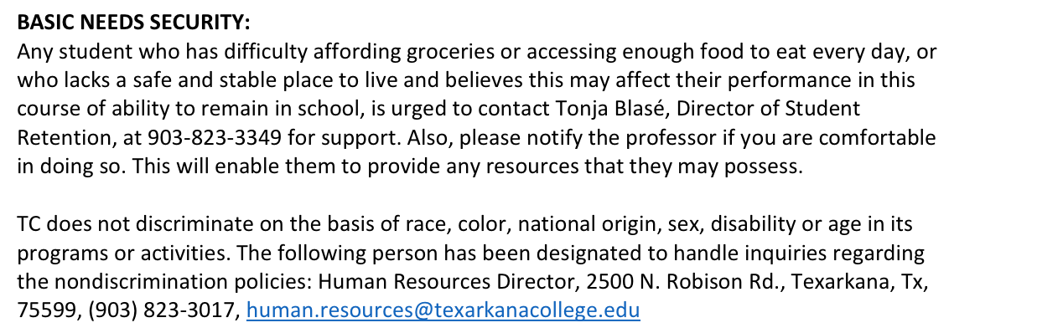

- Alternate Operations during Campus Closure

In the event of an emergency or announced campus closure due to a natural disaster or pandemic, Texarkana College may need to move to altered operations and course delivery methods. During this time, Texarkana College may opt to continue delivery of instruction through methods that include, but are not limited to: online learning management system (Jenzabar or Moodle), online conferencing through TEAMS, email messaging, and/or an alternate schedule. It is the responsibility of the student to monitor Texarkana College's website (www.texarkanacollege.edu) for instructions about continuing courses remotely, instructor email notifications on the method of delivery and course-specific communication, and Texarkana College email notifications for important general information.

