

**Syllabus:** Drawing II   
**Course Number:** ARTS 1317  
**Semester & Year:** Fall 2021

**Instructor Information**

Name: Dr. Angela Melde  
 Office: 903-823-3277  
 Telephone: 903-276-7784  
 E-mail: angela.melde@texarkanacollege.edu  
 Office Hours:  
 Mon./Wed. 3:30 - 5:00

Tues./Thurs. 2:00 - 5:00

Fri. 12:00 - 2:00

**COURSE DESCRIPTION:**

A studio course exploring drawing with continued emphasis on descriptive, expressive and conceptual approaches. Students will further develop the ability to see and interpret a variety of subjects while using diverse materials and techniques. Course work will facilitate a dialogue in which students will employ critical analysis to broaden their understanding of drawing as a discipline.

**STUDENT LEARNING OUTCOMES:**

Upon successful completion of this course, students will:

1. Describe visual subjects through the use of accurate and sensitive observation.

2. Generate drawings that demonstrate descriptive, expressive, and conceptual approaches with an increased focus on individual expression.

3. Utilize varied materials and techniques with informed aesthetic and conceptual strategies.

4. Demonstrate an appropriate level of professional practice, including safety, craft and presentation.

5. Analyze and critique drawings verbally and/or in writing.

6. Relate their drawings to historical and contemporary developments in the field.

**GRADING SCALE**

Grades will be taken drawings, sketchbooks, lab work, and critiques. Grades are also influenced by creativity, attitude, meeting class on time, attendance, cooperation, keeping work area and the student work areas clean.

Sketchbooks are scored at 100 points each. All other quizzes, projects, and extra credit are evaluated at the discretion of the individual instructor. Audio visual materials are shown in conjunction with lectures and textbook materials.

* **STUDIO PROJECTS/PORTFOLIO**: The quality of the work and ability to address the key concepts in each drawing section will be a grading factor. I expect everyone to do their best and meet the total number of assignments given throughout the semester. This may mean giving some extra studio time if needed.

The final digital portfolio is a cumulative portfolio to document your work and record your growth. It will be graded on an extensive rubric that takes into consideration the objectives of the course.

* **LAB HOURS:** You must attend lab class. This is an additional 3 hours a week above the scheduled class time. There will be a sign-up sheet posted.
* **SKETCHBOOK HOMEWORK:**  Students will have homework assignments each day of class, which will be checked and discussed the beginning of class the following week. Occasionally homework will be a written reflection that relates to a topic in the class textbook.
* **CRITIQUES:** All students are required to participate in critiques. Students should plan to

contribute to the discussion about their colleague’s work. Participation as well as personal analysis is part of the critique grade. Critique grade is a balance between student participation and student presentation as well as personal written evaluation (in the form of artists’ statements and/or short essays) Students unprepared to critique their work may receive up to 50% of the points available for participation only.

**Possible Points Projects/Sections**

**700 pts - 7 Drawings**

**100 pts. - LAB hours**

**900 pts. - Sketchbook Assignments (Homework)**

**100 pts. - Critiques (2 @ 50 points each)**

**200 pts. - Final**

**= 2000 pts**

**LAB HOUR GRADES:**

A -- 42 plus hours

B – 31 hours

C – 21 hours

D – 11 hours

F – 9 hours

Final grades will be assigned a letter grade. Throughout the semester, section

assignment grades will be calculated in a point system. ALL ASSIGNMENTS ARE DUE THE DAY SPECIFIED ON THE SYLLABUS CALENDAR, AT THE BEGINNING OF CLASS ON THAT ASSIGNED DAY. Students must consult with the instructor to see if work will be accepted after the due date, or accepted with a penalty of one full grade reduction.

**ATTENDANCE AND CONDUCT:**

* Drawing requires consistent, focused engagement. Students must be on time, fully present and ready to work. It is recommended students show up five to 10 minutes early to set up. Class Participation is required. It is important to come to class

prepared so you can take part in the group discussions and critiques. You are

expected to arrive to class on time and stay the entire period. Leaving early is

the same as a tardy.

* All missed activities and work will need to be made-up outside the regular class. You are

responsible for the information missed by an absence. Make an appointment to see me for missed lectures. You are responsible for what you have missed.

* Excessive tardiness and absences will be referred to the Associate Dean of Arts & Sciences.
* You are expected to attend class regularly. Excessive absences may result in a failing grade. In this class, “excessive absences” is defined as missing more than 4 times.
* After four unexcused absences, you will be dropped from the course with a failing grade.

**Attendance Policy**: (Student Handbook <https://texarkanacollege.edu>)

MW classes – students will be dropped after 4 absences

TTH classes – students will be dropped after 4 absences

Night classes – students will be dropped after 2 absences

Mini classes – students will be dropped after 1 absence

Three tardies equal one absence.

Please contact your instructor if you see you are going to be absent or late. Leave a message at 903-276-7784 or call the Humanities Dept. at 903.823.3360 and leave a message with her.

ON-LINE COURSES

In an online course, you are not required to show-up at a particular time. However, you are expected to be present each week. This course is designed to be an active and interactive course in which you contribute and respond to the contributions of others. You should plan to log on and participate in the course **at least 3-5 times each week**. I will measure this by recording the date of each entry you make to the system--a response to an assignment, an entry into the threaded discussion, submission of an assignment, or participation in group work. **Please do not "drop out" for a period of time and then expect to "drop back in."** If personal issues or illness requires you to be absent, please contact me.

**MAKE-UP POLICY**:

Unit Tests must be made-up before the next unit test is given either in the classroom or the testing center. All other make-up work is at the discretion of the individual instructor.

**ACADEMIC INTEGRITY**

Scholastic dishonesty, involving but not limited to cheating on a test, plagiarism, collusion, or falsification of records will make the student liable for disciplinary action after being investigated by the Dean of Students. Proven violations of this nature will result in the student being dropped from the class with an “F”.

This policy applies campus wide, including TC Testing Center, as well as off-campus classroom or lab sites, including dual credit campuses. This information can be found in the Student Handbook at <https://texarkanacollege.edu>.

Disability Act Statement:

Texarkana College complies with all provisions of the Americans with Disabilities Act and makes reasonable accommodations upon request. Please contact Tonja Blase at 903.823.3349, or go by the office of Disability Services located in the Academic Commons (library) for personal assistance. If a student qualifies for accommodations from the TC Director of Disability Services indicating that he or she has a disability that requires academic accommodations, the director will send an email to the instructor so accommodations can be made. *It is best to request these changes at the beginning if not before the start of class* so there is ample time to make the accommodations.

Financial Aid:

***Attention!*** Dropping this class may affect your funding in a negative way! You could owe money to the college and/or federal government. Please check with the Financial Aid office before making a decision.

**BASIC NEEDS SECURITY**

**Any student who has difficulty affording groceries or accessing enough food to eat every day or who lacks a safe and stable place to live and belies this may affect their performance in this course ability to remain in school, is urged to contact Tonja Blasé, Director of Student Retention at 903-823-3349 for support. Also, please notify the professor if you are comfortable in doing so. This will enable them to provide any resources they may possess.**

*TC does not discriminate on the basis of race, color, national origin, sex, disability or age in its programs or activities. The following person has been designated to handle inquiries regarding the nondiscrimination policies: Human Resources Director, 2500 N. Robison Rd., Texarkana, TX, 75599, (903) 823-3017,* [*human.resources@texarkanacollege.edu*](mailto:human.resources@texarkanacollege.edu)

**SUPPLIES:**

**See Attached List - The TC bookstore will have most of the supplies in a packet for a discounted price.**

\***Where to purchase supplies**

TC Bookstore

Michaels, Hobby Lobby

*ANY WORK, NOTEBOOKS OR SUPPLIES LEFT IN THE ART DEPARTMENT AFTER ONE SEMESTER BECOMES THE PROPERTY OF THE ART DEPARTMENT.*



* **Alternate Operations during Campus Closure**

In the event of an emergency or announced campus closure due to a natural disaster or pandemic, Texarkana College may need to move to altered operations and course delivery methods. During this time, Texarkana College may opt to continue delivery of instruction through methods that include, but are not limited to: online learning management system (Jenzabar or Moodle), online conferencing through TEAMS, email messaging, and/or an alternate schedule.  It is the responsibility of the student to monitor Texarkana College's website ([www.texarkanacollege.edu](http://www.texarkanacollege.edu/)) for instructions about continuing courses remotely, instructor email notifications on the method of delivery and course-specific communication, and Texarkana College email notifications for important general information.

*TC does not discriminate on the basis of race, color, national origin, sex, disability or age in its programs or activities. The following person has been designated to handle inquiries regarding the nondiscrimination policies: Human Resources Director, 2500 N. Robison Rd., Texarkana, TX, 75599, (903) 823-3017,* [*human.resources@texarkanacollege.edu*](mailto:human.resources@texarkanacollege.edu)

../Phase%208%20COVID-19%20Protocols.pdf

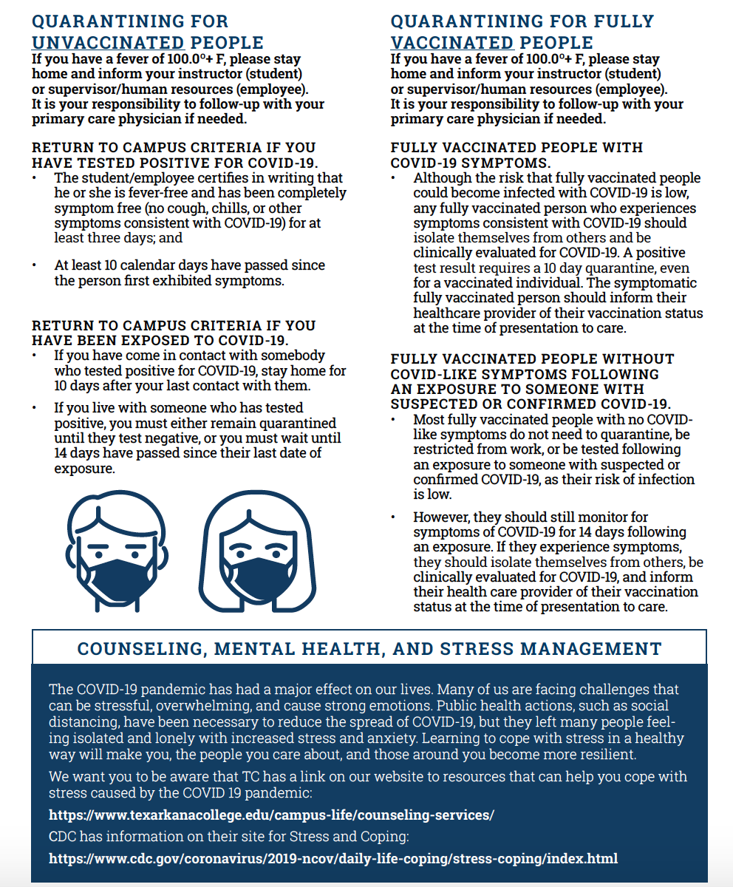



***../Protocols%20for%20Testing%20Positive%20or%20Exposure%20to%20Someone%20Who%20Has%20Tested%20Positive-%20Updated%20August%202021.pdf***