Syllabus
Course Name: Composition II
Course Number: ENGL 1302
Semester & Year:
Instructor Information:
Name: Lynette Fields
Office: C3, New Boston High School
Telephone: 903-628-8515
E-mail: Lynette.Fields@texarkanacollege.edu, LFields@nbschools.net
Office Hours: Monday-Friday 7:40 a.m.-7:55 a.m.; 3:45-4:00

Note: ALL e-mail to instructor MUST be from the student’s Texarkana College e-mail address. The subject line MUST have class name and meeting time.
Textbook Information:
- Writing about Literature, ISBN 97807560293, Pat McKeague, 9th ed.
- Short stories can be accessed through the TC Library web page. Instructions for accessing the stories will be given in class.

Materials needed:
Charged Chromebooks

INFORMATION RELATED TO COVID-19:
Alternate Operations during Campus Closure
In the event of an emergency or announced campus closure due to a natural disaster or pandemic, Texarkana College may need to move to altered operations and course delivery methods. During this time, Texarkana College may opt to continue delivery of instruction through methods that include but are not limited to: online learning management system (Jenzabar or Moodle), online conferencing through TEAMS, email messaging, and/or an alternate schedule. It is the responsibility of the student to monitor Texarkana College's website (www.texarkanacollege.edu) for instructions about continuing courses remotely, instructor email notifications on the method of delivery and course-specific communication, and Texarkana College email notifications for important general information.

COVID-19 Online/Virtual Environment Instructional Commitment
The ongoing COVID-19 situation will require that some course materials and instruction are provided through an online and/or virtual format. Even if all or a portion of a class was originally scheduled to meet face-to-face, social distancing guidelines associated with COVID-19 will limit the number of students who are able to attend face-to-face classes in person simultaneously. Further, circumstances associated with COVID-19 could cause the college to be forced to shift completely to an online and/or virtual delivery at any time during the semester. While TC faculty members are committed to providing students the option of face-to-face instruction if possible, students should be prepared to continue their classes in an online and/or virtual environment if necessary. Texarkana College is committed to maintaining engaging, high-quality instruction regardless of the delivery format.

Course Description:
Intensive study of and practice in the strategies and techniques for developing research-based expository and persuasive texts. Emphasis on effective and ethical rhetorical inquiry, including primary and secondary research methods: critical reading of verbal, visual, and multimedia texts; systematic evaluation, synthesis, and documentation of information sources; and critical thinking about evidence and conclusions.

Prerequisite: Satisfactory completion of ENGL 1301

Student Learning Outcomes for the Course:
Upon successful completion of this course, students will:
1. Demonstrate knowledge of individual and collaborative research processes.
2. Develop ideas and synthesize primary and secondary sources within focused academic arguments, including one or more research-based essays.
3. Analyze, interpret, and evaluate a variety of texts for ethical and logical uses of evidence. 4. Write in a style that clearly communicates meaning, builds credibility, and inspires belief or action.
5. Apply the conventions of style manuals for specific academic disciplines (e.g., APA, CMS, MLA, etc.)

Student Requirements for Completion of the Course:
Students will write at least four essays over the course of the semester that will include an extended literary analysis/research essay and an in-class essay. The extended literary analysis/research essay will be at least 4-6 pages in length, use Modern Language Association (MLA) documentation and format, and require a minimum of five sources. Papers will be evaluated with Texarkana College English Dept. grading rubrics. Students will incorporate the literary elements and poetic devices to analyze various genres of literature. Students will complete one collaborative literary project. Students will take a Short Story Exam and the English 1302 Departmental Pre-test and Post-test (literary terms).

Four major essays or three major essays and a literary project will be assigned including Literary Research Paper. Each essay will be worth up to 200 points with the exception of the Literary Research Paper that will be worth 250 points. 50% of the overall grade will come from the essays and literary project. Reading quizzes over the assigned short stories, collaborative work, in-class assignments and other work as assigned (including planning and drafts of essays) will make up 20% of the grade. 30% of the overall course grade will come from one short story exam (final), a literary terms exam, a reading response journal, and one in-class essay.

*Failure to turn in any one of the three essays or the reading response journal will result in a failing grade for the course.

Student Assessment:
Essays: 50%
Essays will be recorded as follows:
Character Analysis Essay – Content 100
Character Analysis Essay-Grammar 100
Literature Criticism Review 100
Extended Literary Analysis Content 100
Extended Literary Analysis Grammar 100
OR Literary Project 200
Literary Research Paper 100
Literary Research Paper – Content 100
Literary Research Paper – Grammar 100
Literary Research Paper – MLA 50
Literary Project 100
Exams: 30%
Short Story Exam 100
Literary Terms Exam 100
Reading Response Journal 100
In-Class Essay 100
Daily Assignments: 20%
Short story quizzes 100
Prewriting/Drafts/Editing 100
Collaborative work/participation 100
All other assignments 100

Student Assessment:
Assignments and Assessments | Percentage of overall grade | # of Activities | Total Percentage of Final Grade
Essays/Project | 50% | 3 Essays  1 Project | 50%
Exams  Reading Response Journal  In-Class Essay | 30% | 2 Exams  1 Journal  1 In-Class Essay | 30%
Daily Assignments  Short Story Quizzes | 20% | Daily Work | 20%
Total Points/Percentage Possible |  |  | 100%

Grading Scale:

Grade
A | 90-100
B | 80-89
C | 70-79
D | 60-69
F | 59-below

ABSENTEE POLICY
Texarkana College’s absentee policy allows instructors to withdraw a student from a course due to excessive absences. If a student leaves and returns during class or leaves the class before the class is over, he/she may be considered absent. Three tardies constitute one absence. In this class, students arriving more than 15 minutes after the scheduled start time will be considered absent. Students leaving early will be considered absent.

In some vocational areas, such as nursing and cosmetology, certification requirements necessitate an absentee policy that is more stringent than the institutional policy. In these instances, the matter of certification takes precedence over local policies, since certification policies are established by the State of Texas.

Faculty members are not obligated to provide opportunities for students to make-up missed assignments and tests as a result of a student’s absence from class.

Do not stop attending a class without formally withdrawing from the course by the institution’s published Last Day to Drop. If a student does not attend class and does not withdraw from the class, the student will receive a grade of F in the class. The published Last Day to Drop applies to students; an instructor may withdraw a student for excessive absences at any time during the semester.
Withdrawal from a course(s) may affect a student’s current or future financial aid eligibility. Students should consult the Financial Aid Office to learn both short and long term consequences of a withdrawal.

EXCUSED ABSENCES
A student’s absence due to school trips and/or school business will not be counted against a student’s allowable number of absences. Military duty and absences for Holy Days (FBD LEGAL) are covered in a separate section of the catalog and the student handbook. These are the only types of absences that are considered excused by Texarkana College. Responsibility for work missed for any absence is placed on the student. Instructors are required to allow students to make up work missed if the absence is due to military duty or religious holy days when students follow the correct notification procedures. Instructors are not required to allow students to make up work for absences due to other reasons. Make-up policies are listed in each individual instructor’s syllabus.

MAXIMUM ALLOWABLE ABSENCES:
After official registration, the following number of unexcused absences will be the maximum allowable before a student may be dropped from the class.

Academic Classes:
A COURSE THAT MEETS FOR THE FULL 16-WEEK SEMESTER
Class or Lab Meets:  Once a week (Night or Friday classes)  Twice a week (MW or TR classes)  Three times a week (MWF or TRF classes)  Four times a week (MTWR classes) | An instructor may withdraw a student from a course if absences exceed:  2  4  6  8  Three tardies count as one absence

Financial Aid:
Attention! Dropping this class may affect your funding in a negative way! You could owe money to the college and/or federal government. Please check with the Financial Aid office before making a decision.

Drop Date:
The official drop date for the course is ____________, which is the last date for the student to drop this course with a W. The instructor may drop the student at any time during the semester.

Make-up Policy:
If a student misses on a day that an essay is due, the student is still responsible for turning the essay in on time. Major essays are due by the end of the day on the designated due date. Twenty points will be deducted for each day the essay is late. With instructor’s permission, major exams or the in-class essay can be made up in the Testing Center. The Testing Center is located on the first floor of the TC Library. A student will have one week to make up the missed test or in-class essay. After one week, the student will receive a zero for the test. The student must speak to me about placing the test in the Testing Center and provide a legitimate excuse (at my discretion) for missing the test. Daily work (including reading quizzes) cannot be made up; however, the lowest daily grade will be dropped. If a student is excused for a Texarkana College extracurricular activity, religious holiday, or military service, the student must receive prior approval from the Dean of Students and the professor. Assignments must be completed prior to the excused absence.

Note: If you miss a class, check the Class Assignment Calendar or with a classmate to see what you missed.

Academic Dishonesty Policy: Academic Integrity Statement:
Scholastic dishonesty, involving but not limited to cheating on a test, plagiarism, collusion, or falsification of records will make the student liable for disciplinary action after being investigated by the Dean of Students. Proven violations of this nature will result in the student being dropped from the class with an “F”.
This policy applies campus wide, including TC Testing Center, as well as off-campus classroom or lab sites, including dual credit campuses. This information can be found in the Student Handbook at https://texarkanacollege.edu.

Major Essays:
All major essays must have a TYPED and double-spaced rough draft unless otherwise specified in class. Rough drafts must be completed on the day assigned. On this day, each student will edit and revise essays. Each student must bring a copy of his/her rough draft in order to receive daily work points for that day. Students who do not come to class with a rough draft ready on the due date may be asked to leave class and will receive an absence for that day.

Students must turn in all major papers in order to receive a passing grade in the class. Students who fail to hand in the first two major essays within two weeks of the due date will be dropped from the course. Reminder: Late penalty is 20 points per day.

Papers are submitted in MLA style:
- All papers must be typed and double-spaced using 12-point Times New Roman in black ink. Papers that are not double-spaced will not be accepted for grading. Be sure to save all work! Printing kiosks are available around campus.
- Computer emergencies can and do happen, but they will not be an excuse for a late paper.
- Rough drafts and final papers must be turned in together the day they are due.
- Remember to always retain copies of the essays.
- Each essay must have a header on the first page:
Student’s Name
Instructor’s Name
ENGL 1302. (Section Number)
Date (Day Month Year)
- Students should staple paper in top left corner and hand in as follows:
- Final Draft with THESIS STATEMENT HIGHLIGHTED
- EDITED Rough Draft
- Planning/Prewriting Pages as instructed in class
- Special Requirements for the Literary Research Paper:
- Literary Research papers lacking in-text citations will receive a grade of 0 for all components.
- Literary Research Papers lacking a Works Cited page listing sources that are cited in the paper will receive a 0 for all components.
- Literary Research Papers will not be accepted late. NO EXCEPTIONS!

Daily Assignments:
Daily assignments will include reading quizzes over the assigned readings, in-class essay questions, chapter questions, textbook assignments, collaborative work, essay planning, drafting, and editing, and any other work assigned during class. READING QUIZZES CANNOT BE MADE UP.

Non-compliance:
Failure to complete major essays or other writing assignments within two weeks of the due date results in non-compliance. Non-compliance results in being dropped from this course – or a failing grade. Failure to complete any of the three major essays or the reading response journal constitutes non-compliance. Essays that are not accepted for grading as outlined in assignment guidelines are the same as not handing in an essay. Generally, essays that are written in first person, that use internet sources (except where specifically allowed), that lack internal documentation, and/or lack a Works Cited page will not be accepted for grading.

Viewing Grades:
Grades are available for viewing throughout the semester under the student’s MyTC portal.

TC Email:
Students should check their TC Email account on a regular basis to check for general information sent from campus or instructors. Also, when emailing the instructor, the students should use the TC Email account.

Student Support:
Library Hours
M-Th 7:30 a.m. - 9 p.m. Friday 7:30 a.m. - 4 p.m. Sunday 2-9 p.m.

Student Support Services (Tutoring) in Library second floor
M-Th 8 a.m.-7 p.m. Friday 8 a.m. - 4 p.m. Sunday 2-9 p.m.

Testing Center (Library first floor)
M-Th 8:30 a.m. – 6 p.m. Friday 8:30 a.m. – 3:30 p.m. Sunday 2-6 p.m.

Class Policies:
- Cell phones must be turned off and out of sight in the classroom. If an emergency situation exists, please let me know about it before class. Students will be warned if a cell phone is out and then asked to leave the classroom with an absence. Students can be dropped from the course if the problem persists.
- Students are not allowed to use a laptop during class without permission.
- There will be a zero tolerance policy for any behavior that is disruptive of classroom learning. This includes any vulgar language or rude behavior toward the instructor or other students in the class. Also, students should not talk while the instructor is teaching. Much of this class calls for student discussion. Please be accepting of views that may differ from your own. A variety of viewpoints and lively discussion often leads to deeper understanding of literature.
- Children are not allowed in class. This is Texarkana College policy.
- Only plastic bottled drinks or cups with lids will be allowed in the classroom.
- Eating in the classroom is not allowed.
- If a problem occurs, students may receive a warning or may be asked to leave the classroom and will receive an absence. Students can be dropped from the course for inappropriate classroom behavior.

If any of the above problems occur, a student may receive a warning or may be asked to leave the classroom and will receive an absence. The student will also be reported to the Dean of Students, Mr. Robert Jones. Students can be dropped from the course for inappropriate classroom behavior.

Students in this course are held accountable to all policies and procedures outlined in the Texarkana College Student Catalog/Handbook.

Please add the number for Campus Security to your cell phone.
The number is 903-823-3330.
All emergency calls should go to TC Campus Security.

NOTE: The above guidelines are subject to amendment at any point during the semester. Students will be notified in class if any changes occur. Students are responsible for any changes after they have been announced in class.

Disability Act Statement:
Texarkana College complies with all provisions of the Americans with Disabilities Act and makes reasonable accommodations upon request. Please contact Tonja Blasé, Director of Retention and Disabilities Services, at 903.823.3349, or go by the office located in the Palmer Memorial Library on the first floor for personal assistance.

If a student has an accommodation letter from the Recruitment, Advisement, and Retention Department indicating that he or she has a disability that requires academic accommodations, the student should present the letter to the instructor so accommodations can be made. It is best to request these changes at the beginning if not before the start of class so there is ample time to make the accommodations.

Needs Statement:
Any student who has difficulty affording groceries or accessing enough food to eat every day, or who lacks a safe and stable place to live, and believes this may affect their performance in this course or ability to remain in school, is urged to contact Tonja Blasé, Director of Student Retention, at 903.823.3349, for support. Furthermore, please notify the professor if you are comfortable in doing so. This will enable them to provide any resources that they may possess.

TC does not discriminate on the basis of race, color, national origin, sex, disability or age in its programs or activities. The following person has been designated to handle inquiries regarding the nondiscrimination policies: Human Resources Director, 2500 N. Robison Rd., Texarkana, TX, 75599, (903) 823-3017, human.resources@texarkanacollege.edu

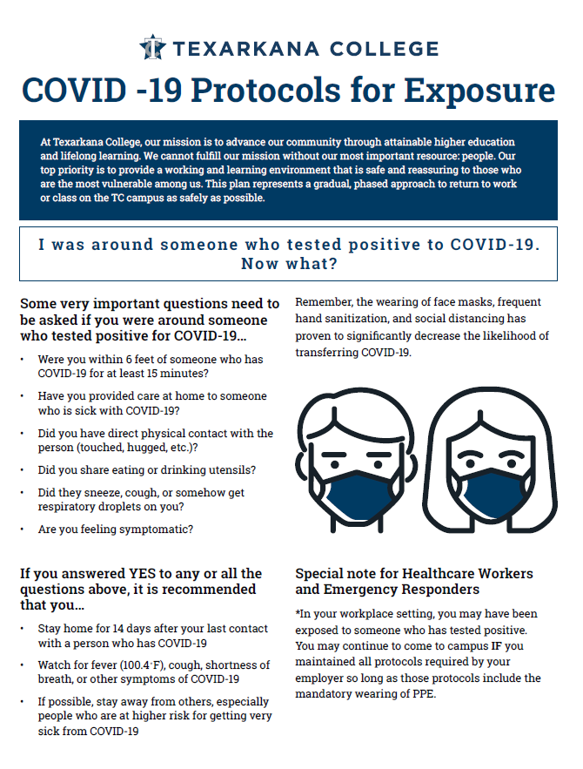
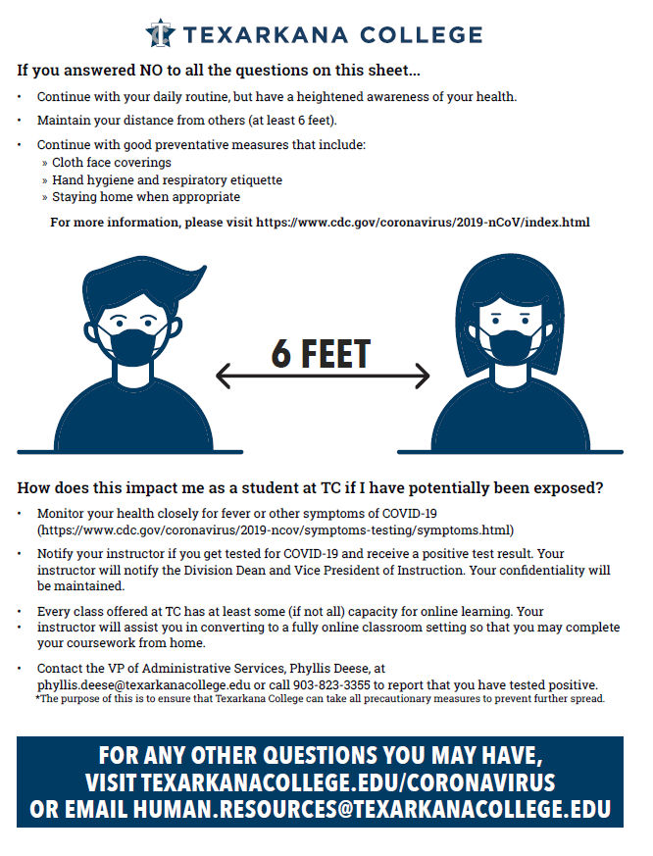

Class Schedule:
This is a general schedule. Additions and modifications to this schedule may occur throughout the semester. The dates and amendments announced in class will override this schedule.

Week 1 | Class Information  Course Pre-Assessment
Week 2 | Begin Short Story Unit  Readings, Discussion, and Activities; Writing About Literature: Ch. 1, The Elements of Literature
Week 3 | Readings, Discussion, and Activities; Writing About Literature: Ch. 2  Readings, Discussion, and Activities; Writing About Literature: Ch. 3; Using quotations and paraphrasing from readings; intext citations
Week 4 | Readings, Discussion, and Activities; Writing About Literature: Ch. 4; Assign Character Analysis Essay  Readings, Discussion, and Activities; Character Analysis Essay Thesis, Outline, and Rough Draft workshopping
Week 5 | Character Analysis Essay Rough Draft DUE with peer editing and student/teacher conference  Readings, Discussion, and Activities
Week 6 | CHARACTER ANALYSIS ESSAY DUE Readings, Discussion, and Activities  Writing About Literature: Ch. 5 and 8, Discuss Theme and Symbolism Analysis; Assign Literary Criticism Review
Week 7 | Readings, Discussion, and Activities; Writing About Literature: Ch. 6-7, Discuss Setting and Point of View  WORKDAY: Literary Criticism Review
Week 8 | EXAM: Short Stories and Readings  Begin Poetry Unit, Readings, Discussion, and Activities  LITERARY CRITICISM REVIEW DUE
Week 9 | Readings, Discussion, and Activities; Writing About Literature: Ch. 14, Assign Extended Literary Analysis  WORKDAY: Extended Literary Analysis
Week 10 | Readings, Discussion, and Activities; READING JOURNAL DUE  Extended Literary Analysis Rough Draft DUE with peer edit and student/teacher conference
Week 11 | Begin Novel Unit with Independent Study Assignments  Extended Literary Analysis Paper DUE
Week 12 | Assign Literary Research Paper  Workday: Literary Research Paper/Novel Assignments
Week 13 | Workday: Literary Research Paper/Novel Assignments  Workday: Literary Research Paper/Novel Assignments
Week 14 | Workday: Literary Research Paper/Novel Assignments  Literary Research Paper Rough Draft DUE with peer edit and student/teacher conference
Week 15 | DUE: Literary Research Paper  Independent Novel Study Presentations
Week 16 | FINAL EXAM: Literary Terms

