Spring SEMESTER 2021

OIL PAINTING II
Course Number: Arts 2317
Instructor: Dr. Angela Melde
Contact:
Phone: 903-276-7784
Office Hours
Mon./Wed. 3:30 - 5:00
Tues./Thurs. 2:00 - 5:00
Fri. 12:00 - 2:00

TEXT RESOURCES: NOT REQUIRED (These are resources I will refer to in class)
The New Artist’s Manual: A Complete Guide to Painting and Drawing Materials and Techniques by Simon Jennings, San Francisco, CA: Chronicle Books, 2006
The Elements of Color by Johannes Itten (Translated by Ernst Van Hagen), New York: Van
Nostrand Reinhold Company, 1970
Interaction of Color by Josef Albers, New Haven & London: Yale University Press, 2013,
Artistic Anatomy by Dr. Paul Richer, translated by Robert Beverly Hale New York: Watson Guptill Publications, 1971.
Anatomy Lessons from the Great Masters by Robert Beverly Hale and Terence Cole New York: Watson-Guptill Publications, 1977.

COURSE DESCRIPTION: Studio art course that introduces the fundamental principles, materials, and techniques of painting. Prerequisite Painting I

STUDENT LEARNING OUTCOMES:
Upon successful completion of this course, students will:
1. Generate works that demonstrate descriptive, expressive, and conceptual approaches.
2. Apply the elements of art and principles of design.
3. Use varied materials and techniques with informed aesthetic strategies.
4. Analyze and critique works verbally and/or in writing.
5. Relate painting to art history and contemporary artistic production.
6. Demonstrate an appropriate level of professional practice, including safety, craft, and presentation.

COURSE OBJECTIVES:
- Develop student’s expertise - technically, conceptually, and professionally
- Formalize student’s ability to verbally articulate ideas, artistic processes, and personal expression.
- Nurture student’s ability to establish personal focus and direction as artists.
- Help students create a body of painting that has consistency and sophistication.
- Exhibit work in Art Exhibition

COURSE CONTENT & SCOPE:
- Color Theory: Color wheel (primary/secondary, complementary), transparency/opacity, hue, value (intensity, brightness), chroma (saturation, purity) & temperature (warm/cold).
- Color Contrast & Attributes: Interaction, harmony, psychology/mood, culture & expression.
- Composition: Space, movement, balance, asymmetry, rhythm, shapes, proportion & lighting.
- Media Characteristics & Surfaces: Acrylic, oil, paper, wood & canvas (primed/unprimed).
- Painting Techniques: Alla prima, glazing, impasto, knife painting, scumbling & blending.
- Perspective: Linear (one, two, and three point, Aerial, and Shifting perspective
- Proportion: Golden Section
- Acrylic & Oil Mediums: Gel medium (heavy/regular/soft, gloss/semi-gloss/matte), texture medium, linseed oil, mineral spirit, turpentine, odorless turpenoid, retouch varnish & final varnish.
- Image Interpretation: pictography, realism, stylized, cubism, & abstraction
- Painting History: Major painting styles & masters in Renaissance, Realism, Impressionism, Post-impressionism, Expressionism, Modernism, Abstract Expressionism & Postmodernism
- Anatomy

STUDENT ASSESSMENT
- STUDIO PROJECTS/PORTFOLIO: The quality of the work and ability to address the key concepts in each drawing section will be a grading factor. I expect everyone to do their best and meet the total number of assignments given throughout the semester. This may mean giving some extra studio time if needed.
The final digital portfolio is a cumulative portfolio to document your work and record your growth. It will be graded on an extensive rubric that takes into consideration the objectives of the course.
- LAB HOURS: You must attend lab class. This is an additional 3 hours a week above the scheduled class time. There will be a sign-up sheet posted.
- CRITIQUES: All students are required to participate in critiques. Students should plan to
contribute to the discussion about their colleague’s work. Participation as well as personal analysis is part of the critique grade. Critique grade is a balance between student participation and student presentation as well as personal written evaluation (in the form of artists’ statements and/or short essays) Students unprepared to critique their work may receive up to 50% of the points available for participation only.
- RESEARCH: Research and class presentation are important parts of this course. The class will be divided into teams to research on specific artists, styles and art movements. Each team needs to organize their findings and thoughts and then present (with images of artwork in ppt) to the whole class. This assignment measures students’ research ability, comprehension of materials, depth of study, organization, presentation, as well as effectiveness of social interaction for the sake of
achieving group goals.

GRADING CRITERIA:

Possible Points Projects/Sections
600 pts. - 6 Finished Paintings
100 pts. - LAB hours
100 pts. - Critiques (2 @ 50 points each)
200 pts. - Final
=
1000 Total points

LAB HOUR GRADES:
A -- 42 plus hours
B – 31 hours
C – 21 hours
D – 11 hours
F – 9 hours

Final grades will be assigned a letter grade. Throughout the semester, section
assignment grades will be calculated in a point system. ALL ASSIGNMENTS ARE DUE THE DAY
SPECIFIED ON THE SYLLABUS CALENDAR, AT THE BEGINNING OF CLASS ON THAT ASSIGNED
DAY. Students must consult with the instructor to see if work will be accepted after the due
date, or accepted with a penalty of one full grade reduction.

ATTENDANCE AND CONDUCT:
- Drawing requires consistent, focused engagement. Students must be on time, fully present and ready to work. It is recommended students show up five to 10 minutes early to set up. Class Participation is required. It is important to come to class
prepared so you can take part in the group discussions and critiques. You are
expected to arrive to class on time and stay the entire period. Leaving early is
the same as a tardy.
- All missed activities and work will need to be made-up outside the regular class. You are
responsible for the information missed by an absence. Make an appointment to see me for missed lectures. You are responsible for what you have missed.
- Excessive tardiness and absences will be referred to the Associate Dean of Arts & Sciences.
- You are expected to attend class regularly. Excessive absences may result in a failing grade. In this class, “excessive absences” is defined as missing more than three times.
- After four unexcused absences, you will be dropped from the course with a failing grade.

- Attendance Policy: (Student Handbook https://texarkanacollege.edu)
MW classes – students will be dropped after 4 absences
TTH classes – students will be dropped after 4 absences
Night classes – students will be dropped after 2 absences
Mini classes – students will be dropped after 1 absence
Three tardies equal one absence.

Please contact your instructor if you see you are going to be absent or late. Leave a message at 903-276-7784 or call the Humanities Dept. at 903.823.3360 and leave a message with her.

MAKE-UP POLICY:
Unit Tests must be made-up before the next unit test is given either in the classroom or the testing center. All other make-up work is at the discretion of the individual instructor.

ACADEMIC INTEGRITY
Scholastic dishonesty, involving but not limited to cheating on a test, plagiarism, collusion, or falsification of records will make the student liable for disciplinary action after being investigated by the Dean of Students. Proven violations of this nature will result in the student being dropped from the class with an “F”.
This policy applies campus wide, including TC Testing Center, as well as off-campus classroom or lab sites, including dual credit campuses. This information can be found in the Student Handbook at https://texarkanacollege.edu.

DISABILITY ACT STATEMENT:
Texarkana College complies with all provisions of the Americans with Disabilities Act and makes reasonable accommodations upon request. Please contact Larry Andrews at 903.823.3283, or go by the Recruitment, Advisement, and Retention Department located in the Administration building for personal assistance.
If you have an accommodation letter from their office indicating that you have a disability, which requires academic accommodations, please present it to me so we can discuss the accommodations that you might need for this class. It is Best to request these changes at the beginning if not before the start of class so there is ample time to make the accommodations.

FINANCIAL AID:
Attention!!! Dropping this class may negatively affect your funding! Please check with the Financial Aid office before making a decision.

BASIC NEEDS SECURITY:
Any student who has difficulty affording groceries or accessing enough food to eat every day, or who lacks a safe and stable place to live and believes this may affect their performance in this course of ability to remain in school, is urged to contact Tonja Blasé, Director of Student Retention, at 903-823-3349 for support. Also, please notify the professor if you are comfortable in doing so. This will enable them to provide any resources that they may possess.

TC does not discriminate on the basis of race, color, national origin, sex, disability or age in its programs or activities. The following person has been designated to handle inquiries regarding the nondiscrimination policies: Human Resources Director, 2500 N. Robison Rd., Texarkana, Tx, 75599, (903) 823-3017, human.resources@texarkanacollege.edu

SUPPLIES:
See Attached List - The TC bookstore will have most of the supplies in a packet for a discounted price.

*Where to purchase supplies
TC Bookstore
Michaels, Hobby Lobby
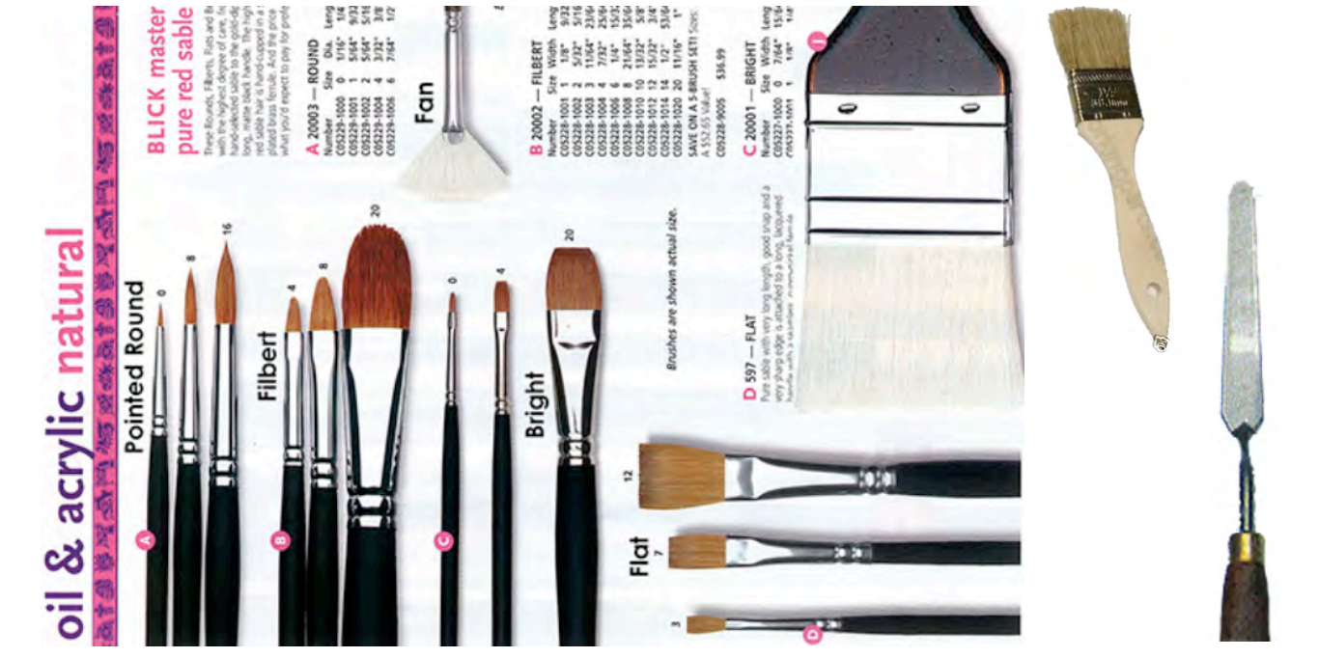

TC does not discriminate on the basis of race, color, national origin, sex, disability or age in its programs or activities. The following person has been designated to handle inquiries regarding the nondiscrimination policies: Human Resources Director, 2500 N. Robison Rd., Texarkana, TX, 75599, (903) 823-3017, human.resources@texarkanacollege.edu

Alternate Operations during Campus Closure

In the event of an emergency or announced campus closure due to a natural disaster or pandemic, Texarkana College may need to move to altered operations and course delivery methods. During this time, Texarkana College may opt to continue delivery of instruction through methods that include, but are not limited to: online learning management system (Jenzabar or Moodle), online conferencing through TEAMS, email messaging, and/or an alternate schedule. It is the responsibility of the student to monitor Texarkana College's website (www.texarkanacollege.edu) for instructions about continuing courses remotely, instructor email notifications on the method of delivery and course-specific communication, and Texarkana College email notifications for important general information.

COVID-19 Online/Virtual Environment Instructional Commitment

The ongoing Covid-19 situation will require that some course materials and instruction are provided through an online and/or virtual format. Even if all or a portion of a class was originally scheduled to meet face to face, social distancing guidelines associated with Covid-19 will limit the number of students who are able to attend face to face classes in person simultaneously. Further, circumstances associated with Covid-19 could cause the college to be forced to shift completely to an online and/or virtual delivery at any time during the semester. While TC faculty members are committed to providing students the option of face to face instruction if possible, students should be prepared to continue their classes in an online and/or virtual environment if necessary. Texarkana College is committed to maintaining engaging, high quality instruction regardless of the delivery format.

