**1.5 Applications and Modeling with Quadratic Equations**

**Geometry Problems**

**CLASSROOM EXAMPLE 1 Solving a Problem Involving Volume**

A piece of machinery produces rectangular sheets of metal such that the length is twice the width. Equal-sized squares measuring 10 cm on a side can be cut from the corners so that the resulting piece of metal can be shaped into an open box by folding up the flaps. If specifications call for the volume of the box to be 7500 cm3, find the dimensions of the original piece of metal.

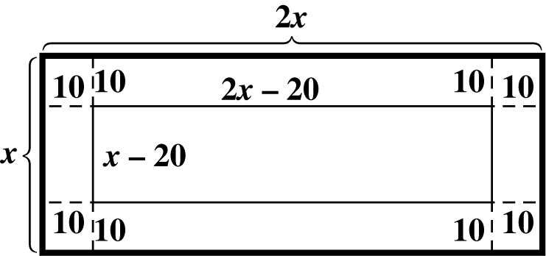 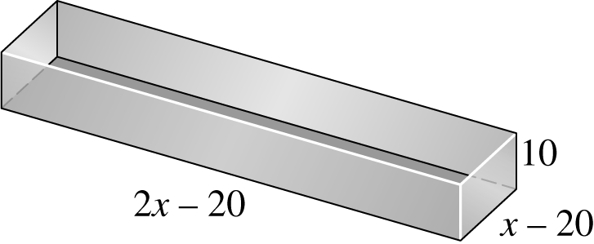

**The Pythagorean Theorem**

|  |  |
| --- | --- |
| **Pythagorean Theorem**  In a right triangle, the sum of the squares of the lengths of the legs is equal to the square of the length of the hypotenuse. | MyNotes01-05-pyth thm2 |

**CLASSROOM EXAMPLE 2 Applying the Pythagorean Theorem**

|  |  |
| --- | --- |
| A piece of property has the shape of a right triangle. The longer leg is 10 m shorter than twice the length of the shorter leg and the hypotenuse is 20 m longer than the length of the longer leg. Find the lengths of the sides of the triangular lot. | Ex01-05-02 |

**Height of a Projected Object**

**CLASSROOM EXAMPLE 3 Solving a Problem Involving Projectile Height**

If a projectile is launched upward from the ground with an initial velocity of 73.5 m per sec, neglecting air resistance, its height *s* (in meters) above the ground *t* seconds after projection is given by



**(a)** After how many seconds will the projectile be 100 m above the ground?

**(b)** How long will it take for the projectile to return to the ground?