Syllabus: Anatomy and Physiology I
Course Number: BIOL 2301
Semester & Year:
Instructor Information
Name: Katie Teer
Office: Biology 31
Telephone: 903-823-3433
E-mail: kathleen.teer@texarkanacollege.edu
Office Hours:
Days | Times
Monday/Wednesday | Varies by semester
Tuesday/Thursday | Varies by semester
Friday | By appt. only

Required Materials

a) Textbook: Openstax Anatomy and Physiology, 2nd Edition

Publish Date: Apr 20, 2022 ISBN-13: 978-1-711494-06-7

b) Booklet of A&P 1 Handouts – purchased from the TC Bookstore

b) Access to internet to take quizzes and obtain course materials

c) Green Scantron #882 (at least 2)

Optional Materials

Pens, binder for handouts, colored pencils, markers, highlighters, index cards

Textbook Information
Open Stax – Anatomy and Physiology
To download the book, go to https://openstax.org/details/books/anatomy-and-physiology-2e
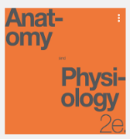
The textbook is an open source textbook developed by Rice University.

There are several ways to access the Textbook that is required for this class.
- a) $$ - You can purchase a copy of the textbook at:
- TC Bookstore
- Amazon
- b) free You can download it as a PDF to your computer, tablet, phone, etc. for free
from the Rice
OpenStax website.
https://assets.openstax.org/oscms-prodcms/media/documents/AnatomyandPhysiology-OP.pdf
- c) free You can view the live Web version for FREE to any device with internet access
https://openstax.org/books/anatomy-and-physiology/pages/1-introduction

Student Learning Outcomes for Biol 2301 – Anatomy & Physiology I (Lecture)
Anatomy and Physiology I is the first part of a two-course sequence. It is a study of the structure and function of the human body including cells, tissues, and organs of the following systems: integumentary, skeletal, muscular, nervous, and special senses. Emphasis is on interrelationships among systems and regulation of physiological functions involved in maintaining homeostasis (ACGM – Spring 2016).
Upon successful completion of this course, students will:
1) Use anatomical terminology to identify and describe locations of major organs of each system covered.
2) Explain interrelationships among molecular, cellular, tissue, and organ functions in each system.
3) Describe the interdependency and interactions of the systems.
4) Explain contributions of organs and systems to the maintenance of homeostasis.
5) Identify causes and effects of homeostatic imbalances.
6) Describe modern technology and tools used to study anatomy and physiology.

Technology Help
7
School Web Address: www.texarkanacollege.edu
If you cannot access internet from home, work, etc., there are places on campus to access your TC Course page and complete the required assignments. You are welcome to use the computers in the TC Library.
If you are in need of help regarding accessing your email or your TC Course page or logging in please contact the TC Service Portal at 903-823-3030 or you may contact them through a working computer at: https://support.texarkanacollege.edu/?sso_token=474125a9e46eab415a7c46bf1f85af33b300f025

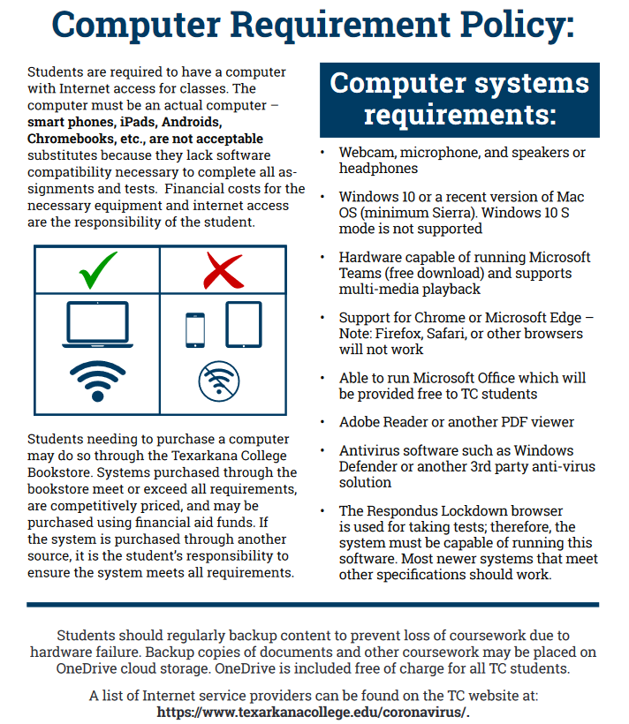
Computer Requirements
All students are required to have a computer with internet access for classes.
- Smart phones, iPads, Androids, Chromebooks, etc., are NOT acceptable substitutes. For more information, please view our Computer Requirement Policy here.
- Need to buy a laptop computer? Check our TC Bookstore. Special student pricing is available and financial aid may be used for the purchase. A list of internet Wi-Fi service providers can be found here.
- Wifi is available on campus for TC students. See our Wifi hotspots on campus here. If you are having trouble accessing TCNet Wifi contact the TC Service Desk:
  - Submit a ticket online
  - Email the Service Desk
  - Call (903) 823-3030

Class Schedule (Varies by Semester)
This class schedule is subject to change. Changes will be announced in class.
Week | Dates | Content | Test Due Dates
Week 1
M/T | --- | ---
W/Th |  | Chapter 1 – Introduction to Anatomy
Week 2 |  |  | Lecture Test 1 – Ch. 1&2 due by the end of the day by ------ in the Testing Center
M/T |  | Chapter 2 – Chemistry Review
W/Th |  | Chapter 3 – Biology Review
Week 3 |  |  | Lecture Test 2 – Ch 3&4 due by ------ in the Testing Center
M/T |  | Chapter 4 – Tissues
W/Th |  | Chapter 5 – Integumentary System
Week 4 |  |  | Lecture Test 3 – Ch. 5 due by ------ in the Testing Center
M/T |  | Labor Day Holiday – No Class
W/Th |  | Chapter 6 Skeletal System
Week 5 |  |  | Lecture Test 4 – Ch. 6-9 due by ------ in the Testing Center
M/T |  | Chapter 7,8, & 9 - Joints
W/Th |  | Chapter 12 – Nervous System
Week 6 |  |  | Lecture Test 5 – Ch. 12 due by ------ in the Testing Center
M/T |  | Chapter 12 – Nervous System
W/Th |  | Chapter 10 – Muscle System
Week 7 |  |  | Lecture Test 6 – Ch. 10 due by ------ in the Testing Center
M/T |  | Chapter 10 – Muscle System
W/Th |  | Chapter 13 – Central Nervous System
Week 8 |  |  | Lecture Test 7 – Ch. 13 due by ------ in the Testing Center
M/T |  | Chapter 13 – Central Nervous System
W/Th |  | Chapter 15 – Autonomic Nervous System
Week 9 |  |  | Lecture Test 8 – Comprehensive Final Exam; ------ IN CLASS
M/T |  | Final Exam Review
W/Th |  | Final Exam – In Person  Bring a Green Scantron and a pencil

Student Assessment – Grade Calculation
Exams 70%
- Multiple choice and essay format with 10 matching word-bits.
- All exams are weighted equally.
- NONE of the assignments in this category will be dropped.
- No late exams will be accepted.
  - Be sure to pay attention to due dates and testing center rules and hours.
- All exams will be taken in 1 of the following ways:
  - Virtually using Moodle which will require the Respondus Lockdown Browser
  - In the Testing Center which is located in the TC Library
  - In the classroom (face-to-face setting) which will require a PENCIL & Green Scantron
- The Final Exam will be IN PERSON during regular class time.
  - You will need a Green Scantron #882 and a pencil to take this exam. Scantrons can be purchased in the TC Bookstore.
  - The grade that is marked on the scantron by the machine will be the basis for your grade posted in the gradebook. Be sure to mark answers carefully so that the machine can read your responses correctly.
- Bonus opportunities are sometimes available for the tests.
  - The maximum test grade for any given test will be 100. This includes bonus points.
  - For example, if you make a 100 on the test and then also earned 5 bonus points – your test grade for that test will still be a 100.
Assignments 30%
- These will be completed either during class time or outside of class as homework.
- The lowest grade in this section will be dropped.
- Assignments will include:
  - Activities on the Moodle Page (quizzes, videos to watch, discussion forums, etc.)
  - Pencil/paper assignments that may be handed out in class to be turned in at another time
  - In class quizzes or activities
- Must be present to receive credit if it is an in-class assignment – no make-up work allowed
- No late assignments will be accepted. Pay attention to due dates.

Grade
A | 90-100
B | 80-89
C | 70-79
D | 60-69
F | 59-below
Grading Scale

Be sure to check the gradebook in Moodle/Jenzabar frequently regarding your grades and attendance.
Once a grade has been entered, you will have 1 week to dispute that grade.
After the time frame has passed for disputes, the grade will be locked in and will no longer be subject to change.
Attendance Policy – non-traditional classes (hybrid, web, hy-flex)
Attendance for internet classes is based on accessing course materials and submitting assignments. If a student stops accessing materials and sending assignments, the date of the last report of activity will be submitted to the Registrar, and a grade of “F” will be recorded. As a result, the student may lose scholarships or grants or have to repay funds already rewarded. The TC absentee policy is pasted below:

Absentee Policy
Texarkana College attendance policy allows students to be dropped by instructors for excessive absences. TC considers excessive absences to equate to anything greater than 15% of the class. In an 8-week term, this means that instructors may drop students for attendance if a student’s absences exceed more than one week of class meetings and/or online assignments. In a 16-week term, instructors may drop students for attendance if student absences exceed more than two weeks of class meetings and/or online assignments.
Faculty members are not obligated to provide opportunities for students to make-up missed assignments and tests due to a student’s absence from class.
A student should not stop attending a class without formally withdrawing from the course by the institutions published Last Day for Students to Drop. If a student stops attending class after the published Last Day for Students to Drop, the student may receive a grade of “F” in the class. The instructor will submit the last date of attendance for students receiving a grade of “F” or “W”.
Withdrawal from a course(s) may affect a student’s current or future financial aid eligibility. Students should consult the Financial Aid Office to learn both short and long term consequences of a withdrawal.

Excused Absences
A student’s absence due to school trips and/or school business will not be counted against a student’s allowable number of absences. Military duty and absences for Holy Days (FBD LEGAL) are covered in a separate section of the catalog and the student handbook. These are the only excused absences that are considered by Texarkana College. Responsibility for work missed for any absence is placed on the student. Instructors are required to allow students to make up work missed if the absence is due to military duty* or religious holy days when students follow the correct notification procedures. Instructors are not required to allow students to make up work for absences due to other reasons. Make-up policies are listed in each individual instructor’s syllabus.

ONLINE/HYBRID COURSE ABSENCES
Absence in an online course is defined as the lack of an active post or submission within the course including discussion board posts, written assignments, and tests. This standard will be used to determine all absentee issues, including but not limited to, 12th Day Census Reports, last date of attendance, and involuntary withdrawal from a course due to absences. All online students must complete an Enrollment Verification activity within the first week of class (activity depends upon the professor); otherwise, the professor may drop the student for not having attended. Students must complete at least one activity in their online class per week. Each week in which a student does not complete an activity will be counted as an absence.
If a student is taking a hybrid course, and it does not meet during the first week of class, the student must also complete an Enrollment Verification activity within the first week of class; otherwise, the student may be dropped for not having attended.
Maximum Allowable Absences
After official registration, the following number of unexcused absences will be the maximum allowable before a student may be dropped from the class. Mandated program certification requirements detailed for certain programs regarding the maximum allowable unexcused absences takes precedence over the following information.
Roll will be taken each class. A student with 3 absences may be dropped from the course for lack of attendance per the TC Handbook Attendance Policy. If extenuating circumstances arise, please set up a time to discuss this with your instructor. If an enrolled student stops attending class and chooses to receive an F, the last date they attended will be listed on the final grade sheet and they will most likely have to pay back money received from grants or scholarships. You can check your absences through myTC (Jenzabar)!

Make-up Policy
No make-up tests or assignments will be allowed. Please be aware of the testing center hours and requirements. No extensions will be provided because the testing center was closed or full and they could not accommodate you.
Testing Center: https://www.texarkanacollege.edu/academics/testing-center/
Class Behavior
There will be a ZERO TOLERANCE policy for any behavior that is disruptive and prevents or deters classroom learning. This includes, but is not limited to, ANY use of vulgar language or rude behavior towards the instructor or any other student in the class. Violation could result in being asked to leave the class, withdrawal from the course, &/or investigation by the Dean of Students.
If a student creates a disruption in the Testing Center, the student could face the following consequences: zero on the assignment (even a test), withdrawal from the course (WF on transcript), &/or investigation by the Dean of Students.
Examples of a disruption include but are not limited to: being rude or disrespectful to the staff in the testing center, academic misconduct (cheating), not following testing center rules and regulations

Financial Aid:
Attention! Dropping this class may affect your funding in a negative way! You could owe money to the college and/or federal government. Please check with the Financial Aid office before making a decision.
If you are dropped from the lecture course for any reason, you will be automatically dropped from the lab course.

Cell Phone Policy
During lecture, cell phones should be on silent (not vibrate) and not be used during the class. During testing, cell phones should NOT be VISIBLE and put on silent (not vibrate). If a cell phone or any other electronic device is visible, regardless of if it is used, it will result in a zero for the assignment and reported to the Dean of Students as academic dishonesty and could lead to being withdrawn from the course with a grade of “F”.

Academic Integrity Statement
Scholastic dishonesty, involving but not limited to cheating on a test, plagiarism, collusion, or falsification of records will make the student liable for disciplinary action after being investigated by the Dean of Students. Proven violations of this nature will result in the student being dropped from the class with an “F”.
This policy applies campus wide, including TC Testing Center, as well as off-campus classroom or lab sites, including dual credit campuses. This information can be found in the Student Handbook at https://texarkanacollege.edu.
The following are examples of academic dishonesty:
1) copying an answer sheet from another student during an exam
2) providing information to another student about a test
3) cell phone usage during an exam (usage refers to ANYTHING that involves a cell phone, including but not limited to: silencing an alarm, viewing documents, texting (viewing or sending), answering a call, browsing the internet, checking the time, etc.)
a) cell phones MUST be concealed and cannot be retrieved during an exam
b) cell phones cannot be answered during an exam (this includes texting)
4) opening other tabs while taking a computerized version of the test (in the testing center or at home)
During an exam (lecture or lab), a student will not be allowed to wear a hat or sunglasses, nor will students be allowed to leave the room unless they are finished with the exam. Once a student has left the exam room, the exam will be considered complete, and the student may no longer make changes or return and continue the exam.
Chat GPT: The use of Chap GPT may be considered academic dishonesty. Check with your instructor to be sure.
The instructor reserves the right to determine what constitutes an act of cheating, although the above are provided as examples.

Disability Act Statement:
Texarkana College complies with all provisions of the Americans with Disabilities Act and makes reasonable accommodations upon request. Please contact Tonja Blasé at 903-823-3349.
If you have an accommodation letter from their office indicating that you have a disability which requires academic accommodations, please present it to the instructor so we can discuss the accommodations that you might need for this class. It is best to request these changes at the beginning, if not before the start, of class so there is ample time to make the accommodations.
If you are dropped from the lecture course, you will be automatically dropped from the lab course.

Basic Needs Security Statement
Any student who has difficulty affording groceries or accessing enough food to eat every day, or who lacks a safe and stable place to live and believes this may affect their performance in this course or ability to remain in school, is urged to contact Tonja Blasé, Director of Student Retention, at 903-823-3349 for support. Furthermore, please notify the professor if you are comfortable in doing so.

