Syllabus: Nurse Aide for Health Care Dual Credit  
Course Number: NURA 1301

**Instructor Information**

Name: Kristi LeJeune, B.L.A. Psychology, RN  
Office: Med Room 222  
Telephone: 903-756-5314 ext 4222  
E-mail: klejeune@lkcisd.net  
Office Hours: call for an appointment Monday-Friday

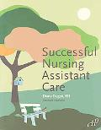**Textbook Information**

Title: Successful Nursing Assistant, 2nd Ed.  
Author: Dugan, Diana

ISBN 13: 9781888343977

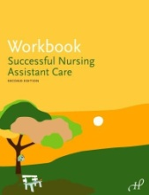Title: Workbook for Successful Nursing Assistant Care, Ed.

Author: Hartman Publishing Inc.

ISBN 13: 9781888343984

**Student Learning Outcomes for the Course**

To prepare nurse assistants with the knowledge, skills and abilities essential for the provision of basic care to residents in long term care facilities. Upon successful completion of the course, students will be able to:

1. Provide basic care to residents of long term care facilities.
2. Communicate and interact effectively with residents and their families based on sensitivity to the psychosocial needs of residents.
3. Assist residents in attaining and maintain maximum functional independence.
4. Protect, support and promote the rights of residents.
5. Provide safety, comfort, and preventive measures in the care of residents.
6. Demonstrate skill in observing and reporting.
7. Function effectively as a member of the health care team.

**Student Requirements for Completion of the Course**

Quizzes:

Quizzes will function as an evaluation of weekly content. A quiz may or may not come with advanced notice.

Homework:

Homework assignments will be made from the workbook and also other assignments will be assigned in class. All assignments must be turned in on time to receive a grade.

Mid-Term Exam:

The mid-term exam will be a comprehensive analysis of the subject matter taught in the first half the course. Date for the mid-term exam will be given in class.

Final Exam:

The final exam will be a comprehensive analysis of the subject matter taught for the entire course.

**Student Assessment**

Students will be assessed by quizzes, workbook, assignments, midterm exam, and final exam with the following grading scale:

Grading Scale:

|  |  |
| --- | --- |
| Grade |  |
| A | 90-100 |
| B | 80-89 |
| C | 70-79 |
| D | 60-69 |
| F | 59-below |

**ASSIGNMENTS NOT HANDED IN ON TIME WILL BE MARKED ZERO UNLESS PREVIOUS ARRANGEMENTS ARE MADE WITH THE INSTRUCTOR.**

**Students who do not make a C or higher in this course are ineligible to take the CNA certification exam from the State of Texas.**

**Class Schedule**

Class time is the high school “B” days. Classroom instruction is a minimum of 80 hours.

Assignment, workbook, and quiz dates will be given out in class. Dates for midterm and final exams will also be given out during class. **It is the student’s responsibility to contact the instructor classes to get assignments, workbooks, and quizzes that were missed due to absence.** All Texarkana College policies apply to the classroom. The Student Handbook is available on the Texarkana College website. [www.TexarkanaCollege.edu](http://www.TexarkanaCollege.edu)

**Absentee / Make-Up Policy**

To be eligible to take the state nurse assistant certification exam, the Department of Aging and Disability (DADs) for the State of Texas requires students to sign in and sign out for class and clinical time.

Ten (10) absences (non-school related) per semester are allowed before the student is dropped from the class. The student will be warned on the 5th absence with a message sent to the high school by the instructor. Upon the 10th absence, the student will be on probation and the high school is notified again. With the 11th absence the student will be dropped. It is the responsibility of the student to cover the material missed on their own time. If a quiz or exam is missed, it is the student’s responsibility to contact the instructor for a make-up time. Quizzes and exams that are missed must be made up within two (2) class days.

**Student Conduct**

1. **NO** cell phones, pagers, or other electronic devices are allowed in class. These may be used at break time only or at discretion of instructor in case of emergency situations.
2. No food or drinks are allowed in the classroom or skills lab.
3. No sleeping in class. Participation and attention are imperative for success.
4. No feet on chairs.
5. Proper, respectful, and professional communication will be used at all times with other students, instructors, clinical site employees, and residents. Cursing and profane language will NOT be tolerated.
6. NO cheating on exams or assignments. This will result in a “0” (zero). This applies to both the person cheating and the person allowing student to copy work.

**Failure to comply with these expectations and those in the Texarkana College Student Handbook will result in a student incident report. On the fourth (4th) incident the student may be dropped from the class.**

**Academic Integrity Statement**

Scholastic dishonesty, involving but not limited to cheating on a test, plagiarism, col­lusion, or falsification of records will make the student liable for disciplinary action after being investigated by the Dean of Students. Proven violations of this nature will result in the student being dropped from the class with an “F”.

This policy applies campus wide, including TC Testing Center, as well as off-campus classroom or lab sites, including dual credit campuses. This information can be found in the Student Handbook at <https://texarkanacollege.edu>.

**Disability Act Statement**

Texarkana College complies with all provisions of the Americans with Disabilities Act and makes reasonable accommodations upon request. Please contact Larry Andrews at 903.823.3283, or go by the Recruitment, Advisement, and Retention Department located in the Administration building for personal assistance.

If you have an accommodation letter from their office indicating that you have a disability which requires academic accommodations, please present it to me so we can discuss the accommodations that you might need for this class. *It is best to request these changes at the beginning if not before the start of class* so there is ample time to make the accommodations..

**Security**

If student is permitted to driving to class by the High School then the following applies.

Please keep your vehicle locked whenever you are away from it. Make sure you don’t leave any valuables in plain sight (purse, phone, laptop). We want you to be safe. You must acquire a TC parking permit and display it in your vehicle. You must also have a TC student ID badge and keep it with you at all times.

**Campus police EMERGENCY line: (903) 798-3330**

**For additional information on college policies, see the Texarkana College Student Handbook.**



Nurse Assistant Course Registration Requirements:

1. All applicants must meet general admission requirements to Texarkana College through their high school Dual Credit program.
2. All applicants must meet with counselor and complete requisite paperwork for participation in this class.
3. All applicants must satisfy the requirements of the Texas Success Initiative. A copy of scores must be submitted by high school. A Dual Credit early admission form must be completed which means signatures of high school administration, student, and parent.
4. Students must show proof of the following:
   1. Physical exam on the Nursing Physical Examination form
   2. Current, negative TB skin test
   3. Complete Hepatitis B immunization series
   4. Meningitis vaccine*
   5. Negative drug screen
5. Students must satisfactorily pass a background check.
6. Students must have current CPR.

*Meningitis vaccination is only required of students under the age of thirty.

Essential Physical Abilities:

1. Stand and walk for 6-8 hours/day.
2. Walk for prolonged periods from one area to another over an 8 hour period.
3. Bend, squat, and kneel.
4. Assist in lifting and moving clients of all age groups and weights.
5. Work with arms fully extended overhead.
6. Use hands for grasping, pushing, pulling, and fine manipulation.
7. Demonstrate eye/hand coordination for manipulation of equipment and the performance of procedures.

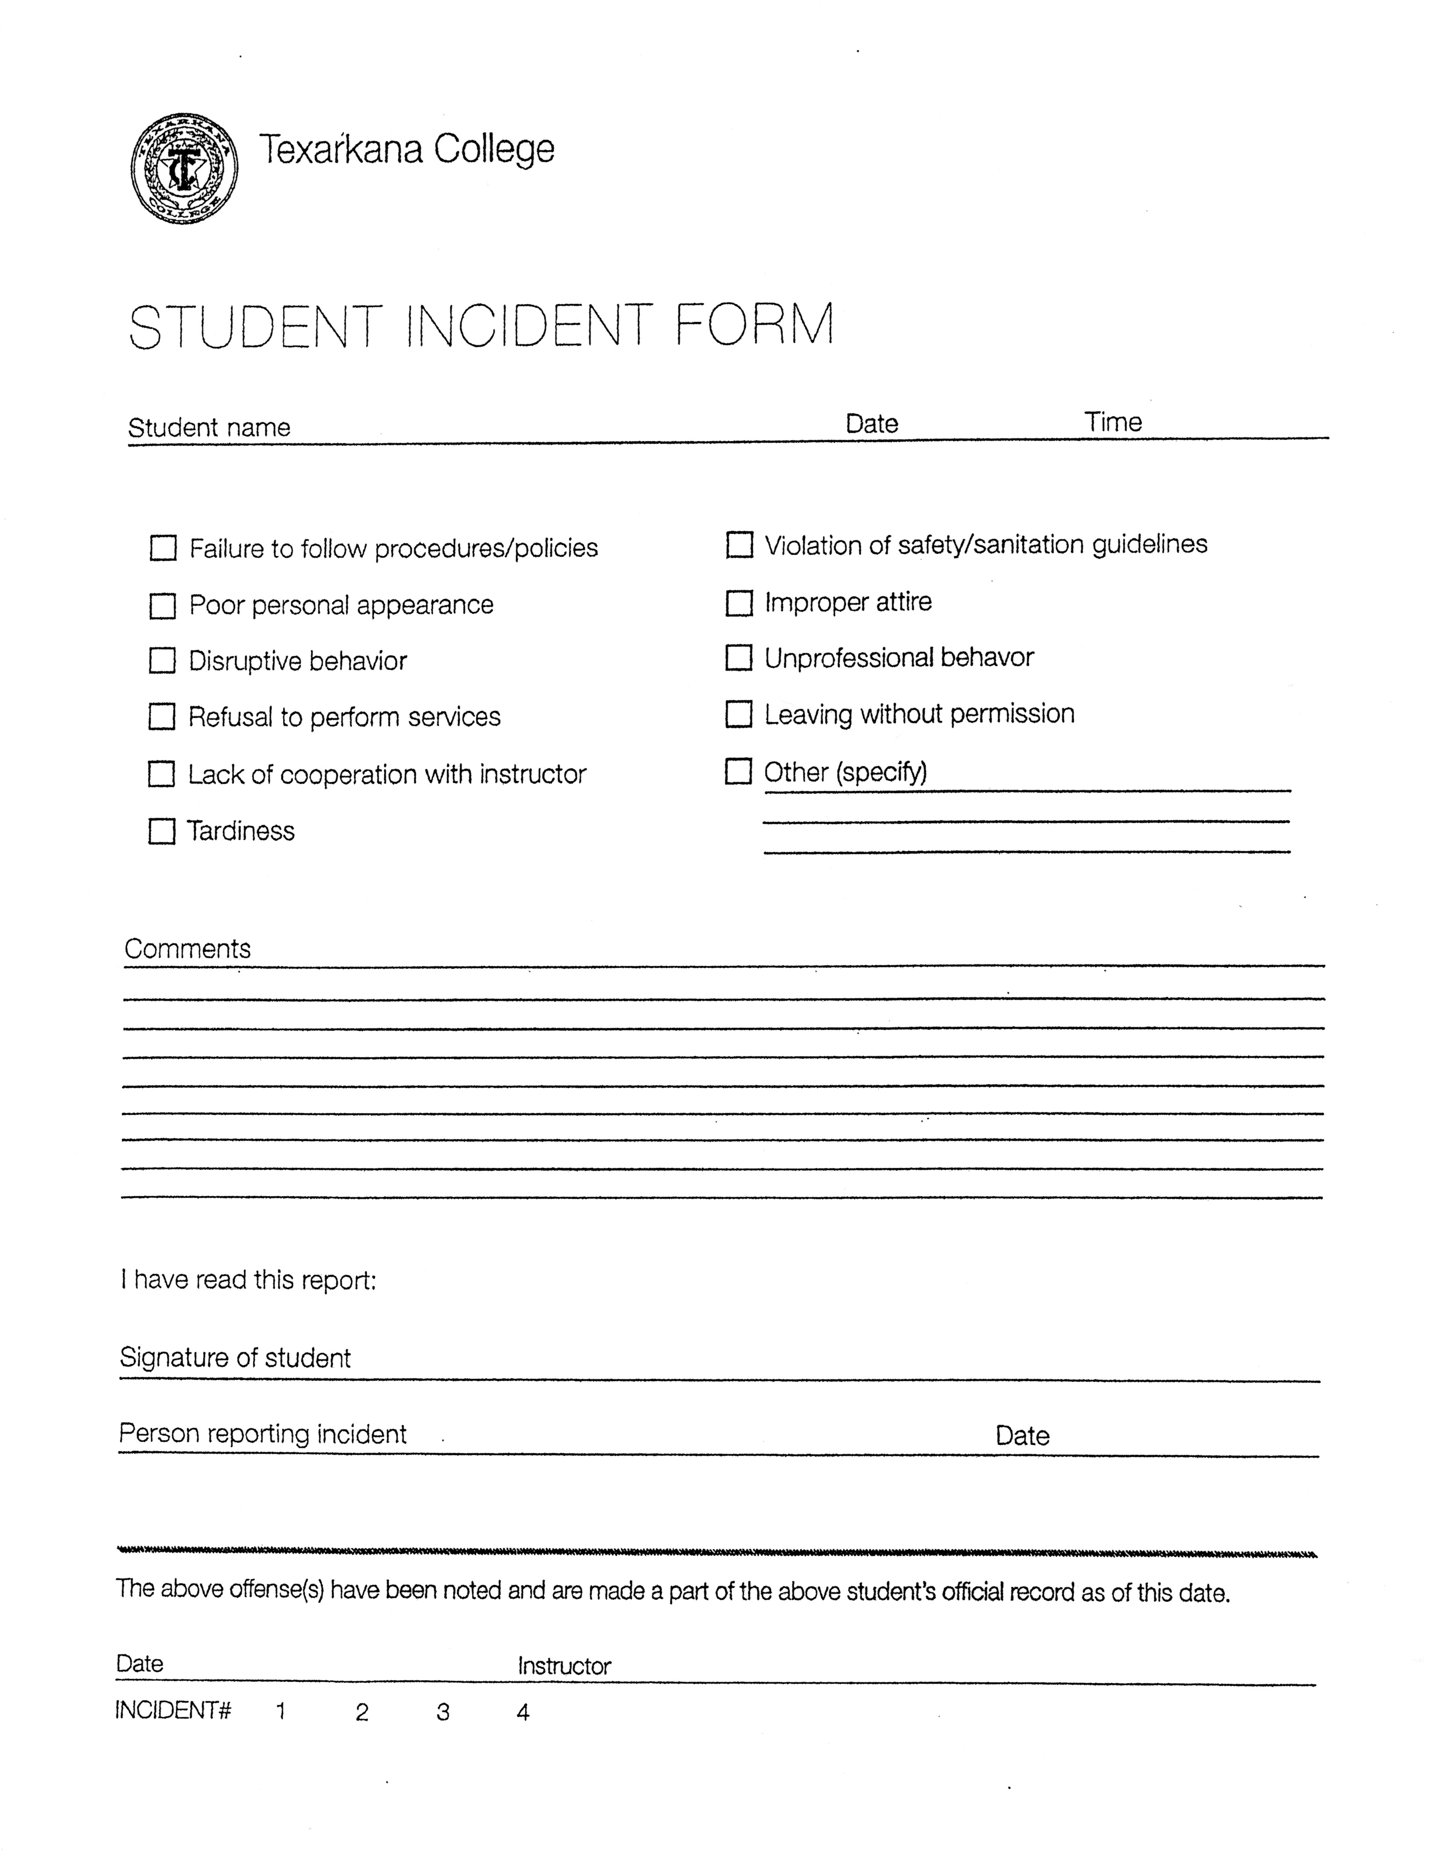 **\*\*\*\*\*\* Texarkana College Policy states that all students must be dropped on the fourth incident report. Students will not receive semester credit if they are dropped from a program.**

**High School: __________________________________________________________**

C:\Users\stephanie.stokes\AppData\Local\Microsoft\Windows\Temporary Internet Files\Content.IE5\XW6WFBJX\MC900353950[1].wmf

**Dual Credit**

**Attendance Policy**

High school students are allowed to miss ten days per semester (non- school related). On the tenth day the student will be placed on probation. If any absence occurs while on probation the student will be dropped.

Each student will be notified in writing following the fifth absence. At this time the school will be notified by the instructor that the student has missed 5 non-school related days. Any time served in ISS will be counted as absent days. School related absences will not be counted. It is the student’s responsibility to notify instructor of school and non-school related absences.

**Warning: (5)**

Student: _______________________________________________________________ Date: _____________________________

Instructor: ______________________________­­­_______ Date: ________________ Number of days missed: ________

**Probation: (10)**

Student: ________________________________________________________________ Date: ______________________________

Instructor: ______________________________________ Date: ________________ Number of days missed: ________

***The next absence will result in termination.***

**Termination:**

Student: ________________________________________________________________ Date: _______________________________

Instructor: ______________________________________ Date: ________________ Number of days missed: _________

I have read and understand this policy.

Student Signature: ________________________________________________________________ Date: ____________________

Parent/Guardian Signature: ______________________________________________