**3.5 Rational Functions: Graphs, Applications, and Models**

**CLASSROOM EXAMPLE 1-3 Graphing a Rational Function**

Graph. Give the domain and range and the largest open intervals of the domain over which the function is increasing or decreasing.

|  |  |  |
| --- | --- | --- |
|  |  |  |
| Dotted_grid_full_10_X_10 | Dotted_grid_full_10_X_10 | Dotted_grid_full_10_X_10 |

**CLASSROOM EXAMPLE 4 Finding Asymptotes of Rational Functions**

Give the equations of any vertical or horizontal asymptotes for the graph of each rational function.

**(a) **

**(b) **

**(c) **

**CLASSROOM EXAMPLE 5 Graphing a Rational Function (*x*-Axis as Horizontal Asymptote)**

Graph 

**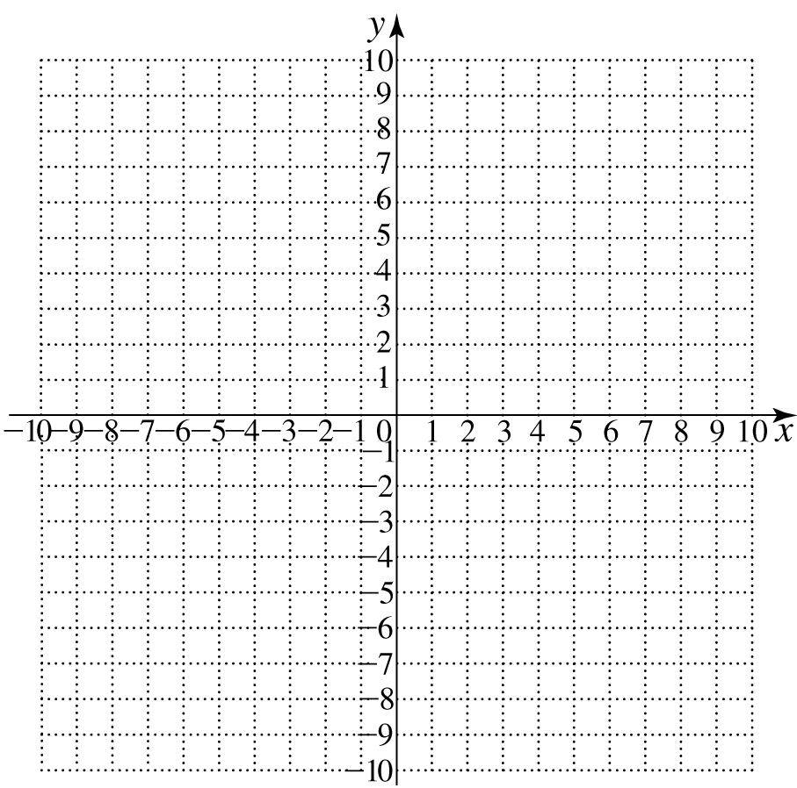**

**CLASSROOM EXAMPLE 6 Graphing a Rational Function (Does Not Intersect Its Horizontal Asymptote)**

Graph 

****

**CLASSROOM EXAMPLE 7 Graphing a Rational Function (Intersects Its Horizontal Asymptote)**

Graph 

****