Syllabus: Art Appreciation
Course Number: ART 1301
Instructor Information:
Name: Deborah Nicholas
E-mail: deborah.nicholas@texarkanacollege.edu

Textbook: The Power of Art, Lewis and Lewis, 3rd Edition
ISBN# 978-1-337-55555-5

Course Description:
A general introduction to the visual arts designed to create an appreciation of the vocabulary, media, techniques, and purposes of the creative process. Students will critically interpret and evaluate works of art within formal, cultural, and historical contexts.

Student Learning Outcomes:
Upon successful completion of this course, students will:
- Apply art terminology as it specifically relates to works of art.
- Demonstrate knowledge of art elements and principles of design.
- Differentiate between the processes and materials used in the production of various works of art.
- Critically interpret and evaluate works of art.
- Demonstrate an understanding of the impact of arts on culture.

Student Assessment
Grades will be taken from unit tests, 3-3-3 discussions, and art work projects. Grades are also influenced by creativity, attitude, meeting class on time, attendance, cooperation, keeping work area and the student work areas clean.

Attendance Policy: (Student Handbook https://texarkanacollege.edu)

MW classes – students will be dropped after 4 absences
TTH classes – students will be dropped after 4 absences
Night classes – students will be dropped after 2 absences
Mini classes – students will be dropped after 1 absence
Three tardies equal one absence.

Please contact your instructor if you see you are going to be absent or late. Email me or call the Humanities Dept. at 903.823.3360 and leave a message with her.

Make-up Policy:

Unit Tests must be made-up before the next unit test is given either in the classroom or the testing center. All other make-up work is at the discretion of the individual instructor.

Academic Integrity Statement

Scholastic dishonesty, involving but not limited to cheating on a test, plagiarism, collusion, or falsification of records will make the student liable for disciplinary action after being investigated by the Dean of Students. Proven violations of this nature will result in the student being dropped from the class with and “F”.

This policy applies campus wide, including the TC Testing Center, as well as off-campus classroom or lab sites, including dual credit campuses. This information can be found in the Student Handbook at https://texarkanacollege.edu.
Disability Act Statement:

Texarkana College complies with all provisions of the Americans with Disabilities Act and makes reasonable accommodations upon request. Please contact Tonja Blasé at 903.823.3283, or go by the Recruitment, Advisement, and Retention Department located in the library for personal assistance.

If you have an accommodation letter from their office indicating that you have a disability, which requires academic accommodations, please present it to me so we can discuss the accommodations that you might need for this class. It is best to request these change at the beginning if not before the start of class so there is ample time to make the accommodations.

Financial Aid:
Attention! Dropping this class may affect your funding in a negative way! You could owe money to the college and/or federal government. Please check with the Financial Aid office before making a decision.

Basic Needs Security:
Any student who has difficulty affording groceries or accessing enough food to eat every day, or who lacks a safe and stable place to live and believes this may affect their performance in this course of ability to remain in school, is urged to contact Tonja Blasé, Director of Student Retention, at 903-823-3349 for support. Also, please notify the professor if you are comfortable in doing so. This will enable them to provide any resources that they may possess.

TC does not discriminate on the basis of race, color, national origin, sex, disability or age in its programs or activities. The following person has been designated to handle inquiries regarding the nondiscrimination policies: Human Resources Director, 2500 N. Robison Rd., Texarkana, Tx, 75599, (903) 823-3017, human.resources@texarkanacollege.edu.

Textbook: The Power of Art, Lewis and Lewis
Art Appreciation Study Packet (from TC Bookstore)
Scantrons for major tests

SUPPLIES FOR DESIGN SKETCHBOOK ARE:
(If you picked up an Art Appreciation Packet from the bookstore with the following cover, DO NOT use the projects suggested. Only use those assigned in MOODLE)
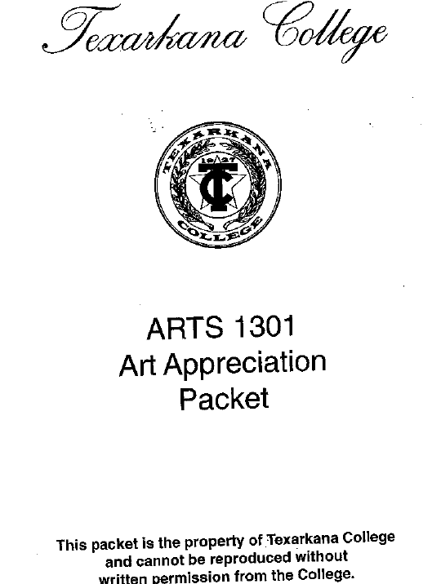
- Glue sticks (not purple)
- Scissors
- Colored copy paper or scrapbook paper 81/2” x 11”
- A box of inexpensive colored markers
- Sketchbook
Other supplies needed during the semester are:

18 X 24” canvas board (NOT stretched)
5 bottles of craft acrylic paint, 2 fl.oz
2 bottles of one color (for the background)
2-3 bottles of assorted colors
Acrylic craft paint can be purchased at Hobby Lobby, Michael’s
and Wal-Mart. Brand name examples of paint are: Ceramcoat,
Apple Barrel, Americana, Folk Art and (in Michael’s hobby
section) CraftSmart.

ANY WORK, NOTEBOOKS OR SUPPLIES LEFT IN THE ART DEPARTMENT AFTER ONE SEMESTER BECOMES THE PROPERTY OF THE ART DEPARTMENT.

