Syllabus: Introduction to Welding Metallurgy
Course Number: WLDG 1337
Semester & Year: Spring 2016
Instructor Information
Name: Phillip Scarborough
Office: Tex Americas
Telephone: 903-823-3289
E-mail: phillip.scarborough@texarkanacollege.edu
Office Hours: 11:00am-11:30am, 2:30pm-3:00pm Monday thru Friday
Tutoring: 11:00am-12:00pm Wednesday’s
Textbook Information 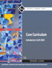 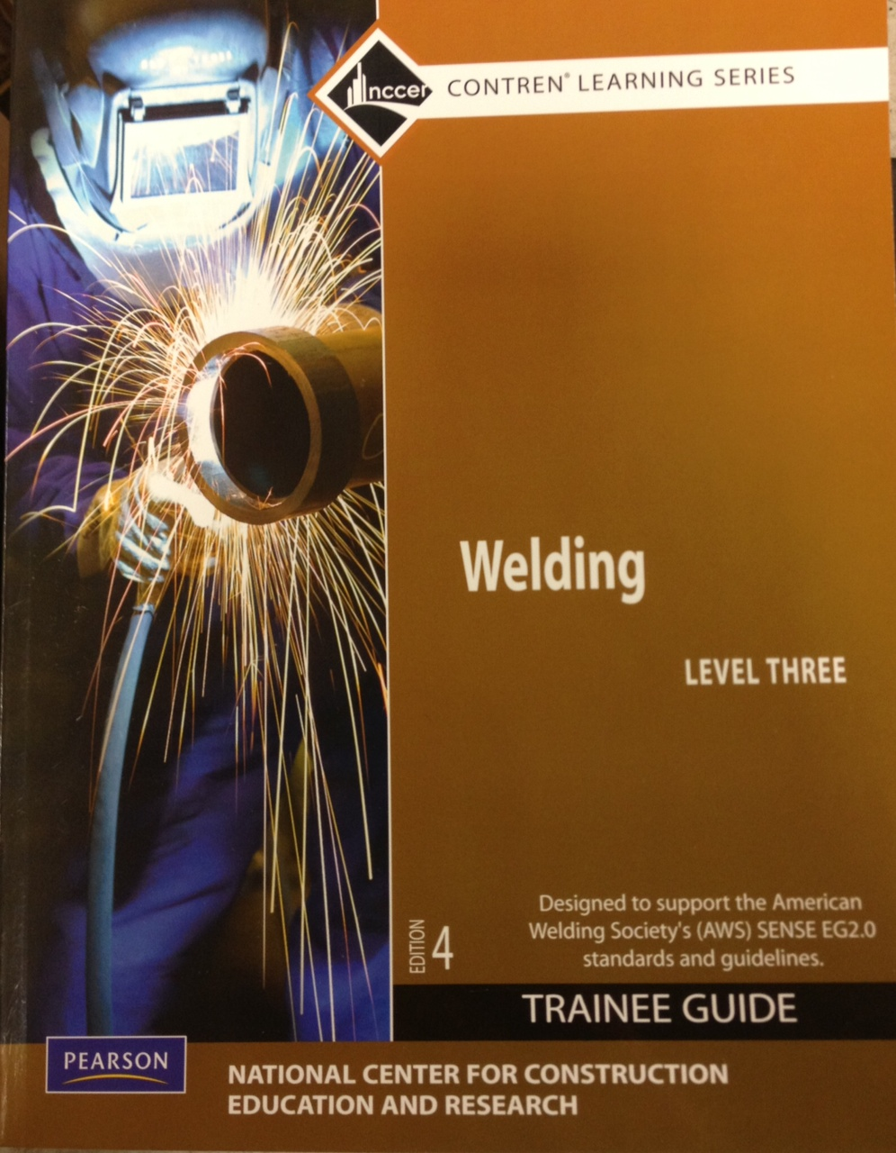

Core Curriculum ISBN#: 978-0-13-608637-6
Core Curriculum online access card: 978-0-13-256093-1
Pearson, Welding Level II ISBN#: 0-13-609970-3
Modern Welding/online access card: 978-1-60960-993-2

Student Learning Outcomes for the Course
Describe technical terms used in the various phases of metallurgy, from early history to classification of steel; discuss ferrous and nonferrous metals and how they are processed and used in industry; and describe mechanical and physical properties, surface treatments, and heat treatment of metals.

Student Requirements for Completion of the Course and Due Dates
Students must complete tests and assignments by the due date given by the Instructor. All students are required to attend all college sponsored events when notified by the instructor.
Student Assessment
Student grades will be determined by written and weld tests as well as work habits and participation. Students will need scantron for testing.

Grading Scale
Grade
A | 90-100
B | 80-89
C | 70-79
D | 60-69
F | 59-below

Class Schedule
Month | Date | Material to be covered
August | 24th | Go over syllabus and Hand book
Oct. | 15th | Mid Term Test
Dec. | 15th | Final Test
Attendance Policy
Students MUST attend class!
5 absences=DROP 3 tardies=1 absence

Make-up Policy
Make-up work must be completed by due date.

Academic Integrity Statement
Scholastic dishonesty, involving but not limited to cheating on a test, plagiarism, collusion, or falsification of records will make the student liable for disciplinary action after being investigated by the Dean of Students. Proven violations of this nature will result in the student being dropped from the class with an “F”.
This policy applies campus wide, including TC Testing Center, as well as off-campus classroom or lab sites, including dual credit campuses. This information can be found in the Student Handbook at https://texarkanacollege.edu.

Disability Act Statement:
Texarkana College complies with all provisions of the Americans with Disabilities Act and makes reasonable accommodations upon request. Please contact Larry Andrews at 903.823.3283, or go by the Recruitment, Advisement, and Retention Department located in the Administration building for personal assistance.
If you have an accommodation letter from their office indicating that you have a disability which requires academic accommodations, please present it to me so we can discuss the accommodations that you might need for this class. It is best to request these changes at the beginning if not before the start of class so there is ample time to make the accommodations.
Financial Aid:
Attention! Dropping this class may affect your funding in a negative way! You could owe money to the college and/or federal government. Please check with the Financial Aid office before making a decision.

